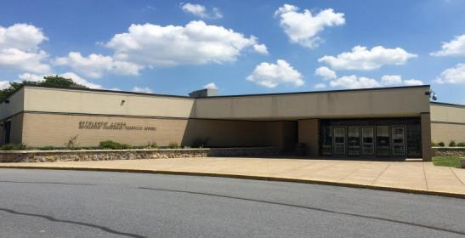







Student Handbook 2025-2026

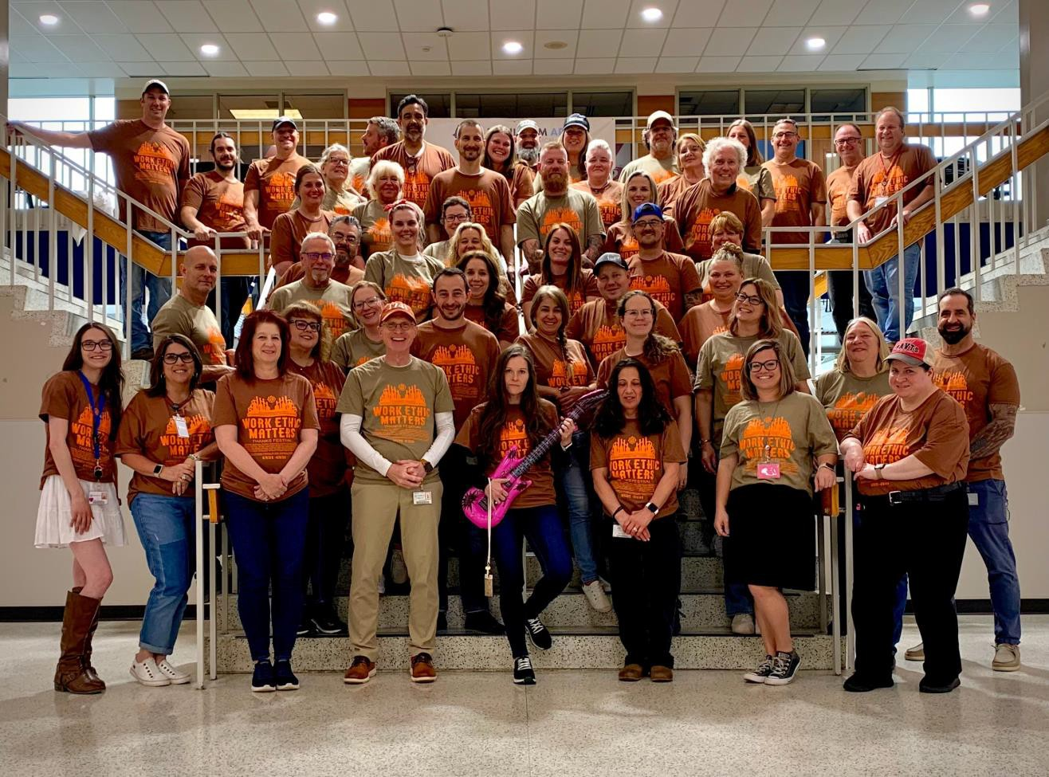

BETHLEHEM AREA



SCHOOL
3300 Chester Avenue
Bethlehem, PA 18020-2895
610-866-8013

Equal Rights and Opportunities Policy
The Bethlehem Area Vocational-Technical School does not discriminate on the basis of race, col- or, national origin, sex, disability or age in its programs or activities and provides equal access to the Boy Scouts and other designated youth groups. Inquiries may be directed to the Bethlehem Area Vocational Technical School’s Business Administrator, Title IX and Section 504 Coordinator, at 3300 Chester Avenue, Bethlehem, PA 18020, via e-mail at complianceofficer@bavts.org or by phone at 610-866-8013, ext. 105.

Visit us at:
www.bethlehemavts.org

Table of Contents

BAVTS Building Info…………………………..1
Policy on Admissions……………………….…..3
Student Attendance………………………….…..4
Grading………………………………………….8
Field Trips………………………………………8
Busing…………………………………………..9
Health Services………………………………...10
Actions and Consequences…………………….13
Dress Code……………………………………..21
Lab Safety…………………………………….. 21
Driving and Parking Regulations…………….. 22
Enforcement of Safety Regulations……………23
Student Organizations…………………………23
Leaving Class/School…………………….……24
Harassment/Bullying…………………………..25
Technology Procedures………………………..27
School Lockers………………………………...30
Electronic Devices……………………………..30
Use of Tobacco/Vaping Products……………...30
Halo Sensors…………………………………...30
BAVTS Lunch Program……………………….31
Student Services……………………………….34
School to Career Program/Co-Op……………..35
School Closing………………………………...37
Family Educational Rights and Privacy Act…….38
Protection of Pupil Rights Amendment…………39
Emergency Drills……………………………….40
Student Work Projects…………………………..40
Lost and Found………………………………….40
Visitors………………………………………….40
Student Insurance……………………………….41
Title IX Notice…………………………………..41
Nondiscrimination Policy………………………..42
Pesticide Letter…………………………………..54
Emergency Drills Letter…………………………55
Parent Reunification Letter………………………57



AM Session (7:50am - 10:45am) | Start | End
Block 1 | 7:50 am | 9:03 am
Block 2 | 9:09 am | 10:45 am
NAHS Lunch Lunch 1 | 10:10 am  10:45 am | 10:40 am  11:15 am
Lunch 2 | 11:15 am | 11:45 am
PM Session (11:45am - 2:35pm)  Block 3 | 11:45 am | 12:52 pm
Block 4 | 12:57 pm | 2:35 pm

Dismissal Times By School AM Session PM Session

Saucon Valley Liberty Freedom
10:15 am 2:05 pm
10:30 am 2:35 pm
10:36 am 2:35 pm

Northampton 10:40 am 2:35 pm
ADMINISTRATION
Adam Lazarchak
Executive Director
Robb Warmouth
Business Administrator

Mike Galler
Supervisor of CTE

Janelle Schaeffer
Supervisor of CTE

Jeff Bower
Supervisor of Building & Grounds

Dennis Nolen
Supervisor of Technology

Joint Committee
Emily Schenkel
Chairperson
Cedric Dettmar
Vice-Chairperson
Sue Fahrenkopf
Secretary/Treasurer
Michael Faccinetto Michael Recchiuti Shannon Patrick Silagh White
Ross Makary Kristin Soldridge Vivian Demko
Jaime Vlasaty
Superintendent of Record
Donald Spry
Esq.Solicitor



Students who drive to school for the start of the AM session are expected to be in class by 7:50 am.


1

Providing Opportunities to Build Careers.

What do you believe?
WE BELIEVE

A positive learning environment will encourage and support students in their efforts towards lifelong learning.

Every student benefits when engaged in active learning, which increases time on task and ability to transfer knowledge.
Assessment and curriculum development are an ongoing process.

Quality career and technical curriculum reflects current business and industry standards.

Every community member will be afforded equal opportunity and access to educational services.

Students should receive a relevant, application-based education in which there is an integration of technical skills with academic instruction as well as an emphasis on developing pathways to career goals.
Students should have access to a structured system of school-based and work-based learning planned cooperatively by educators, employers, employees, parent/guardians, and students.

Students benefit from career guidance which enable them to meet higher expectations and standards.

Students benefit by participating in career and technical student organizations which build goal-setting, teamwork, and leadership skills, and link them to employers.
BAVTS should take a leadership role in making the community more aware of the opportunities available through career and technical education.

Employability Skills for Everyone!
-Practices time management -Demonstrates pride and confidence
-Arrives prepared for class -Works effectively with diverse populations
-Dressed appropriately for work environment -Communicates information effectively
-Able to work independently -Works cooperatively with a team
-Accepts constructive criticism -Organizes and schedules work
-Makes informed decisions. -Exhibits honestly/integrity
-Demonstrates leadership -Demonstrates awareness of community needs
-Demonstrates awareness of business and industry
2


BAVTS - Policy On Admissions

The Bethlehem Area Vocational-Technical School endorses the principle of equal edu- cation and employment opportunities for all people and does not discriminate on the basis of race, color, national origin, religion, age, sex, marital status, or non-related handicaps or disabilities.
All students will be admitted in accordance with the Articles of Agreement of the Bethlehem Area Vocational-Technical School.
No admission procedure will violate legislation or regulation intended to protect the rights of any individual.
All high school students in the approved service area shall be given the opportunity for admission to the Bethlehem Area Vocational-Technical School.
Out-of-school youth and adults may enroll in continuing education programs as approved through Joint Committee Policy and Procedures. There are no residency requirements for admission to adult daytime or evening programs.
Students with disabilities who have Individualized Education Plans (IEP’s) developed under Section (614)(A)
(5) of the Education of the Act, shall, with respect to career and technical education programs, be afforded the rights and protection guaranteed such students under sections 612, 614, and 615 of such Act.
A completed application form is required for all students requesting admission to Area Vocational- Technical School.
Admission to specific career and technical programs will be determined by individual student and/or parent/ guardian choice and by student performance in all 4 rotations. Any conflict resulting from these procedures will be resolved through an established appeals process. In cases of program oversubscription, student placement will be based on multiple factors such as grades and attendance established by full-time equivalent (FTE) district percentage allocation.

Fast Track

What is the Fast Track Program? It's a Career Exploration opportunity for a LIMITED amount of ninth grade students from BASD! This highly competitive program at Bethlehem Area Vocational-Technical School takes place during the 2nd semester of their freshman year. Students rotate through all program areas offered at BAVTS on a flex schedule during blocks 1, 2, 3 or 4 of their school day. By the end of the semester, the students will have an opportunity to apply for a specific program for their 10th grade year (all contingent on Teacher, FT Facilitator & Executive Director approval). This is different from the traditional 10th grade student schedule of rotating through four (4) programs before selecting their program of choice. This program gives the students a clear indication and Fast Track pathway to their potential career goals at the secondary level.

How will the Fast-Track students be graded? Students will be responsible for gathering their performance data from the assigned program instructor, who will provide a daily work ethic grade. The form used to gather this information will be submitted every Monday for the previous week and entered into the grading system by the FT Facilitator.

Due to the program's highly competitive selection criteria for admission, if a student is failing to meet Fast Track requirements during the 3rd marking period, a meeting will take place to discuss whether the student's continuation in the program is feasible.
3

Rotation

At Bethlehem Area Vocational-Technical School (BAVTS), all new students begin the year with a rotation schedule that allows them to explore 4 different career and technical programs for 10-12 days each. This rotation gives students a hands-on sampling of various fields, helping them make an informed decision about their long-term placement. At the end of the rotation cycle, students are placed into a permanent program based on two key factors: their grade during each rotation and their combined average across all four programs during the first marking period. This process ensures that students are matched with a program that aligns with both their interests and demonstrated aptitude. The rotation model helps students discover their strengths while promoting fairness and opportunity across all disciplines.

Student Attendance
Your Presence is Required. . . 180days
Upon returning to school from an absence, the student has three (3) days to present a satisfactory, writ- ten excuse to the school before the school is obligated to change the student’s absence to excused. Failure to submit a written excuse within the “grace period” will result in the absence remaining unexcused. Excuses must be signed by a parent/guardian or doctor. Students who are returning from an excused absence are to submit their excuse to their instructor who will forward it to the attendance office. After ten (10) days of cumulative absence from school in any one (1) school term, each day of absence must be documented by a licensed physician’s certificate for sickness or illness related reasons, a licensed psychiatrist, a licensed psychologist, a licensed therapist, a licensed counselor or similar licensed person for mental health related condition.
4

The mere fact that a parent/guardian has sent a written excuse to the school does not necessarily mean the student absence is “excused.”
Excused &
Excused absences are given only for such rea- sons as the Commonwealth terms as lawful, namely: personal illness, doctor and dental ap- pointments, quarantine, death in the family, im- passible roads, and Absence on the part of the student not within the permissible ab- sences noted above is unexcused. A car problem is not a legally excused absence/tardy.

ATTENDANCE POLICY REGULATIONS
- The following days of absence are classified as “non-cumulative” and are not subject to Attendance Policy Regulations related to the Student Code of Conduct:
  - Suspensions from school.
  - Illness verified by a physician’s note submitted within three days of a student’s return to school.
  - Death in the family, from the date of death until two days after the funeral, unless otherwise authorized by BAVTS Administration. A signed parent/guardian note must be submitted within three days of the student’s return to school.
  - Designated religious holidays provided that a signed parent/guardian request is submitted prior to the holiday.
  - School-sponsored activities.
  - College visits for up to three total days per school year provided that a signed parent/ guardian request is submitted prior to the visit(s).

- The following days of legal excused absence are classified as “cumulative” and are not subject to Attendance Policy Regulations:
VACATION REQUESTS
Parent/guardians requesting release from school for family vacation or personal matters must notify the sending school ten days prior to the date of release. The ap- proved papers must be pre- sented to the attendance office at BAVTS to request other necessary forms. Failure to do so can result in the absence being recorded as unexcused or unlawful.
  - Pre-approved family vacation(s) while school is in session for up to five total days or two separate occasions within a school year.
  - Pre-approved college visits beyond three days within a school year.
  - Any permissible absence for which a written parent/guardian excuse is submitted within three days of the student’s return to school.
    - For school students, a maximum of ten days of cumulative absence verified by parent/guardian notes will be permit- ted during a school year. Beginning with the eleventh day of secondary school stu- dent absence, a physician’s note will be required unless authorized otherwise by BAVTS Administration.
5

ATTENDANCE POLICY REGULATIONS CONTINUED

- The following cumulative absences are classified as “unexcused/unauthorized” and are subject to Attendance Policy Regulations related to the Student Code of Conduct:

  - Any day of absence for which neither a written parent/guardian or physician’s note is
submitted within three school days of a student’s return from absence.
  - Any day of absence not excused by a physician’s note after ten days of secondary school absence unless authorized otherwise by administration.
  - School truancy, which includes any unexcused or unlawful absence by students aged six- teen and under.
  - Three unlawful absences will result in sending district and parent/guardian receipt of a written notice of violation of the Attendance Law and may result in prose- cution by the sending district before a district justice in accordance with Section 1333 of the Pennsylvania School Code (Purdon’s Statutes). A written notice to both parents and sending district will also occur for all subsequent absences. Parent/Guardians are subject to fines of up to $300 and possible arrest. Student may also have their driving privileges delayed or suspended as a result of unlawful absences from school.
  - Unlawful class absences exceeding 50% or more of any school day will be classified as an unexcused/unlawful absence for the day.

Tardiness
Time management is an employability skill emphasized at BAVTS. Instructors expect students to arrive to class on time. Continual lateness to class/lab causes delays in instructional time and shows a lack of concern toward other students who want to learn.
All students, including Academy students, who arrive late to class/lab are required to scan their BAVTS ID that is located at the entrance of the main lobby Students who fail to check –in using their BAVTS ID will remain absent for attendance recording.
Student’s tardiness will be recorded with a “TE” for tardy excused or “TU” for tardy unexcused and the time of the tardy. Students who miss more than 50% of class will be marked absent for that training day. Being late will also impact a student’s Daily Work Ethic grade and depending on the length of missed time, a zero could result for the Daily Work Ethic grade.

Make-Up Work Due To Absence
Students who miss assignments because of an excused absence will be able to make up those class assignments upon their return to class. The student has two days to complete assignments for each day absent. Additional time may be granted by the instructor. Long-term assignments given two weeks or more in advance are due on the date assigned by the instructor; however, the instructor has the option to extend a due date for a student. Parent/Guardians should contact the instructor to determine assignments and deadlines for long-term absences of four days or more. Arrangements to make up missed class assignments are the responsibility of the student
6


EDUCATION IS EVERYONE’S BUSINESS!

It starts with the student:
- Being prepared for class is the student’s responsibility.
- Completion and submission of assignments and/or projects is the student’s
responsibility.
- Putting forth effort on a project to the required specifications is the student’s
responsibility.

Continues with the faculty and staff at BAVTS:
All instructors have the “responsibility” to engage the student in the classroom, and to motivate the
student to succeed. Administrators, in turn, have the responsibility to support instructors in their efforts, and to administer appropriate assistance to encourage a change in negative student behavior. Not meeting the expectations above can result in student failure. These signs of failure should first be addressed by the instructor. Once methods such as student conferences, calling home, and the revoking of classroom privileges have been exhausted, the issue should be addressed through the student’s guidance counselor. When student achievement is affected by misbehavior or not following rules and procedures, the instructor will follow the code of conduct. This will continue until such a time as the student either is willing to change the behavior or reaches the level of a habitual offender and is recommended for removal from BAVTS and, if warranted, expulsion.

Supported by family, friends, and community:
It is the responsibility of the parent or guardian to support the student with educational goals and to make sure that they are following through with district expectations. Family, friends, and community needs to stress the importance of education and career goals to ensure future success for all students at BAVTS.
7

GRADING
The grading system at BAVTS is unlike the traditional grading that takes place within high schools.

BAVTS has a school-wide Grading Policy where students are graded in three specific areas: Knowledge, Skills/Tasks and Work Ethic.
25% KNOWLEDGE: Students will be learning a new career field and will be completing tests, quiz-
zes, exams and homework. This area of grading focuses on the student’s “HEAD” 25% SKILLS/TASKS: Students will be learning in lab envir onments where they will be completing hands-on training. This area of grading focuses on the student’s “HANDS”
50% WORK ETHIC: From beginning to completion of training at BAVTS, students are evaluated daily on their performance within the program. Their ability to stay on task, be punctual, be in uniform, etc. are crucial in the development of sought after employees. This area of grading focuses on the student’s
“HEART”


FIELD TRIPS
Field trips are viewed as an extension of the classroom, and a vital part of the career and technical as well as the academic curricula. As such, they are designed to include all students. However, student behavior can determine eligibility for participation in field trips.

Because field trips are an extension of the classroom, all school code of conduct
guidelines and classroom regulations are enforced and students are expected to behave accordingly.
A field trip may necessitate a change in students' normal transportation in which they take a different bus at a different time to and/or from their home school. This information will be shared by the staff member organizing the field trip.


As per school policy field trips are not scheduled after the Memorial Day holiday (exceptions can be made based on administrative discretion and extenuating circumstances).

8

The Fantastic Voyage
STUDENTS WHO RIDE ON THE SCHOOL BUS
Staff will be notified of late bus arrivals or situations that may cause students to be late. Students who arrive to class/lab after 7:50 A.M. without an approved written excused tardy from the attendance office are considered late.
Students driving to school should allow sufficient time to arrive to school on time. Bus transportation is pro- vided to all students from their sending schools. Driving to school is a choice made by the student. Car problems that occur while driving to school are not considered a valid excuse for being tardy. A student driving to school, or who is a passenger, is considered tardy if they are late arriving to class/lab; unless notification is received by the administration in advance from a parent/guardian. However, it is at the discretion of the ad- ministration to determine if the tardy, due to unusual circumstances, will be excused or unexcused.

BUSING
Each sending school district provides transportation by bus for all students; BAVTS recommends use of this service.
Every effort is made at each sending
and at BAVTS to see that buses do not leave
early and consequently cause students to miss their bus. Students are expected to follow the bus
schedule and arrive on time for the bus.
BAVTS is not responsible for transportation of students who miss their afternoon buses. Missing the bus is not considered an excusable absence from school.


Bus Conduct and Safety Code
- Ride only assigned bus.
- All school rules apply while on the bus.
- Never stick hands, arms, feet, head or any other body part out of window or doors.
- Never tamper with the bus or any equipment.
- Noise and distractions on the bus must be kept to a minimum. Loud talking, yelling, horseplay, or other ways of creating a disturbance are not allowed.
- Roughhousing or throwing objects in or from the bus is prohibited.
- If seats are assigned, students are expected to sit in the seat assigned to him or her.
- Use of speakers and radios is not permitted.
- The use of obscene language is not permitted.
- Smoking/vaping/tobacco use is not permitted by the students or driver.
- The driver is in charge of the bus. Students who risk the safety of others by misbehavior or by causing distractions may lose the privilege of riding the bus.
9

- If a student intentionally damages seats or other parts of the bus, he/she will be required to pay for repairs or replacement.
- Students are to remain in their seats while the bus is in motion.
- Except for student lunches, no food or bever- ages are permitted on the school bus without prior approval from administration.

HEALTH SERVICES
The First Aid Officer is available to assist with the physical, mental, and emotional well-being of each student and thereby is charged with the responsibilities of assessing the health needs of each child, dispensing medications as prescribed by a physician, and communicating special health related information to staff and parents, as needed.
After a nursing assessment is completed, if the student’s condition warrants dismissal from school, a parent or emergency designee will be contacted to pick the student up. Unless medically indicated, every attempt is made to keep the student in school. Under no circumstances should a student who is ill leave school without seeing the nurse. Parent / guardian permission needs to be obtained before releasing student to someone who is not on the contact list.
The school nurse is not responsible for treating injuries/illnesses that occur outside of the school day.
Medication Administration in School:
Please call your First Aid Officer if you have any questions.
Prescribed Medication
- Must have a written physician’s order on file in the First Aid Officer’s office. Students may obtain an authorization form from the First Aid Officer. Written permission slips from parents WILL NOT be accepted.

- Medications will be given in school only in exceptional circumstances when the child's health may be jeopardized without it. A written statement from the prescribing doctor or dentist shall be required. This statement shall include the name of the medication, the dose, the time to be given and possible reaction if any. Please call your school nurse for the required form. Parent signature is also required.

- This procedure must be followed for prescription as well as over the counter medications.

- Medication must be in the original, labeled container with the pharmacist’s instructions secured to the outside. The
medication must be taken to the First Aid Officer’s office.
10

  - The medication must be brought to school in the original, labeled container marked with:
    - Name of student
    - Name of physician
    - Name of medication
    - Time to be given
    - The dosage
- At NO time is medication to be carried by students. Medications include cough medicine, aspirin, decongestants, etc. The only exception to this will be with a physician’s note registered in the First Aid Officer’s office, which allows the student to carry an Epi-pen, inhaler and glucagon.

- All medications will be administered by the school First Aid Officer. Students are responsible to report to the Health Room at the appropriate time for medication to be given.

- The First Aid Officer will maintain a record of the name of the student to whom medication may be administered, the prescribing physician, the dosage and timing of medication and a notation of each administration.

- All medication prescribed by a physician must be brought to the school First Aid Officer’s office and shall be picked up at the end of the school year or the end of the school day. Those medications not picked up at the end of the school year will be disposed of properly.

- In the event medication must be given during a field trip, please call your school nurse before the trip so that appropriate and safe arrangements can be made. Please note that health service staff do not accompany students on field trips.

Over-The-Counter Standing Orders
- Tylenol (Acetaminophen), Advil (Ibuprofen), Claritin (Loratadine), Tums (Antacid), Eye Drops, Cough Drops, Aloe Gel, Hydrocortisone Cream, Burn spray / Gel, Antibiotic ointment (Neosporin, Triple Anti-biotic Ointment)
- can be administered for minor discomfort under the standing order of our school physician at the discretion of the school
nurse. A written consent form with parent signature must be on file in the student’s health record.
Student Possession of And Self-Administration of Asthma Inhalers And Other Medications
In accordance with the Pennsylvania School Code, a student may be permitted to possess and self-administer an asthma inhaler for treating acute asthma if authorized by a treating physician. In order for the BAVTS’ First Aid Officer to approve the possession of an asthma inhaler by a student, the student's parent/guardian must first submit to the First Aid Officer a Permission to Self-Administer Medication form signed by the student's parent/guardian and physician, indicating their opinion that the student should be permitted to carry the medication in the school setting. In appropriate and necessary situations, case by case arrangements for self- administration of other medications may be made contingent on physician recommendation and parent/guardian approval. The student must notify the nurse immediately following each use of the asthma inhaler. The student must provide assurance to the First Aid Officer that she/he will not permit any peers to possess or use the asthma inhaler. BAVTS shall retain the right to restrict a student's self-use of any inhaler, including through confiscation, if appropriate school policies are abused or ignored. When self-administration is authorized, parents/guardians should know (and are hereby informed) that BAVTS bears no responsibility for ensuring that the medication is taken. After providing written authorization, a parent/guardian also fully releases BAVTS from any and all liability relating to the consequences of or arising out of a student's use or non-use of any asthma inhaler. Refer to Medications Policy # 210 and Possession/Use of Asthma Inhalers/Epinephrine Auto Injectors Policy # 210.1
11

When to Keep Your Child Home
Certain symptoms in children may suggest the presence of a communicable disease. Excluding an ill child may decrease the spread of the disease to others in the child care and school settings. Recommended exclusion varies by the disease or infectious agent. Children with the symptoms listed below should be excluded from the child care or school setting until symptoms improve, or a healthcare provider has determined that the child can return.

Exclude children with any of the following:
- Illness: Unable to participate in routine activities or needs more care than can be provided by the child care/school staff.
- Fever: Elevation of body temperature above normal when accompanied by behavior changes, stiff neck, difficulty breathing, rash, sore throat, and/or other signs or symptoms of illness; or is unable to participate in routine activities. Measure temperature before giving medications to reduce fever.
- The following temperatures are considered above normal: Oral temperature: 100 degrees F or higher
- Signs/Symptoms of Possible Severe Illness: Exclude until a healthcare provider has done an evaluation to rule out severe illness when the child is unusually tired, has uncontrolled coughing, unexplained irritability, persistent crying, difficulty breathing, wheezing, or other unusual signs for the child.
- Diarrhea: Until 24 hours after diarrhea stops or until a medical exam indicates that it is not due to a communicable disease. Diarrhea is defined as an increased number of stools compared with a child's normal pattern, along with decreased stool form and/or stools that are watery, bloody, or contain mucus.
- Vomiting: Until 24 hours after vomiting stops, unless determined to be caused by a non-communicable condition and the child is not in danger of dehydration.
- Mouth Sores with Drooling: Until a medical exam indicates the child may return or until sores have healed.
- Rash with Fever or Behavior Change: Until a medical exam indicates these symptoms are not those of a communicable disease that requires exclusion.
- Eye Drainage: When purulent (pus) drainage and/or fever or eye pain is present or until a medical exam indicates that a child may return.
121


Bethlehem Area Vocational-Technical School

BAVTS, like sending districts, is bound by
the Commonwealth of Pennsylvania Regulations and Guidelines on Student Rights
and Responsibilities, Pennsylvania Code, Title 22, Education. The policy statement on Student Rights and Responsibilities is available in the Student Service Center. To further summarize the rights, as well as the responsibilities of the students, the following guidelines have been established.
Code of Conduct


THE OBJECTIVE OF DISCIPLINE
At the heart of effective discipline is the development of attitudes, ideas, and understanding by the students that will eventually result in self-discipline as an adult. Discipline is also character education in that it devel- ops worthy standards and habits of conduct. It is an integral and important component of all the school’s pro- grams. As the student grows in character, he/she comes to understand more fully the consequences of his/her decisions and acts in accordance with that understanding. BAVTS challenges students to achieve the highest attainable academic, technical, and employability skills to meet the changing needs of today’s society. If stu- dents are expected to function in a competitive society, they must be given an opportunity to make decisions.
Within any decision-making process, mistakes will be made. Students are expected to make these mistakes, and also to learn from them. Any action taken to correct the behavior is intended to improve attitude and sub- sequent behavior, not to be vindictive.
The most effective education takes place where there is a proper balance between regulation and freedom. By regulation, we do not mean rules arbitrarily conceived and summarily administered, but rather a well-reasoned approach built on the experience of a professionally trained staff capable of utilizing responsible student participation. This, however, does not mean that there are no absolutes.
BAVTS insists upon courtesy, honesty, and respect for the rights and feelings of others--not only with stu- dents, but the professional staff. If these absolutes are violated or other rules and procedures are willfully dis- regarded, it becomes necessary to correct such action or behavior. The school’s corrective or disciplinary alter- natives are limited not only by the law, but more importantly by the degree of communication and cooperation between the home and school. BAVTS will try, in every instance, to seek the most appropriate action and the school will always act in the best interest of the student.
The purpose of discipline at BAVTS is to ensure that a safe and conducive learning environment is provided to all students. BAVTS is committed to instilling in all students a belief in their self, an understanding of their personal responsibilities, and respect for the rights of others. Confrontation, harassment, intimidation, and fighting are not tolerated at this school regardless of who initiates the action. Physical or verbal retaliation to- wards another student or staff member will not be tolerated. All students involved will be held accountable for their actions. Therefore, we expect students will resolve their issues or concerns with other students in a nonviolent and dignified manner.
13

CLASSIFICATION OF STUDENT MISCONDUCT

The following is a list of student misconduct and the subsequent consequences for that misconduct. The list is divided into 4 levels of misconduct, from minor infractions to very serious infractions. Since it is impossible to list every possible incident of misconduct, this listing is not all inclusive; instead, it should be viewed as a listing of examples and subsequent consequences. It should be noted that a continuation of a behavior violating the code of conduct will elicit stricter consequences and that certain infractions (or repeated infractions) will lead to exclusion from school in the form of in-school detention, out of school suspension, or expulsion.

CLASSROOM MANAGEMENT PLANS
Each classroom instructor or team of instructors will review his/her classroom management plan with students. The plan will include a list or description of expected student behaviors and/or prohibited student behaviors within the class, and consequences for failing to adhere to the procedures. shared with parent/ guardians. Consequences implemented by the instructor in the classroom management plan may include but are not limited to: conference with student, conference with parent/guardian, conference with guidance counselor and/or case manager, loss of privileges, student contract, or specially designed assignments.

DISCIPLINE OF STUDENTS WITH DISABILITIES
Students with disabilities who violate the Code of Student Conduct, or engage in inappropriate behavior, disruptive or prohibited activities, and/or actions injurious to themselves or others, which would typically result in corrective action or discipline of students without disabilities, shall be disciplined in accordance with state and federal laws and regulations and Board policy and, if applicable, their Individualized Education Program (IEP) and Positive Behavior Support Plan.
14

Level 1 Misconduct:
Much of what is considered a Level 1 offense is misconduct that occurs in the classroom. It is the instructor’s responsibility to administer discipline in the classroom. However, repetitious disruptive behavior may escalate to insubordination and require the involvement of an administrator. Other incidents of misconduct may occur when students are not under the direct supervision of their regular teacher. As a guideline, any conduct that interferes with the orderly operation of the class or school will be considered a Level 1 offense. Repetition of similar offense may escalate it to a Level 2 offense. All violations should be documented. The following is the list for Level 1 infractions and their consequences.
Level 1 Misconduct
15
Level I Infractions | Warning | ISD (1-3) | OSS (1-  3) | OSS (3-  5) | OSS (5-  10) | Police In- volved
L-100. Cause a Disturbance/Horseplay |  |  | ------ | ------ | ------ | ------
L-105. Disruptive Behavior |  |  | ------ | ------ | ------ | ------
L-110. Dress Code Violation |  |  | ------ | ------ | ------ | ------
L-115. Electronic Device Usage |  |  | ------ | ------ | ------ | ------
L-120. Inappropriate Language |  |  | ------ | ------ | ------ | ------
L-125. Littering |  |  | ------ | ------ | ------ | ------
L-130. No Hall Pass/ Misconduct |  |  | ------ | ------ | ------ | ------
L-135. Public Display of Affection |  |  | ------ | ------ | ------ | ------
L-140. Safety Violation (Minor) |  |  | ------ | ------ | ------ | ------
L-145. Unauthorized Areas |  |  | ------ | ------ | ------ | ------
L-150. Violation of Acceptable Use Policy (technology, internet, etc…) |  |  | ------ | ------ | ------ | -----
L-155. Other (Specify) |  |  | ------ | ------ | ------ | -----

Level II Misconduct:
In general, conduct that can be classified as Level II is a misconduct that causes a serious disruption to the learning environment of the class or school. At this level an administrator will be involved. Discipline may range from a warning to some in-school detention or suspension of instructional privilege. Students will be provided the opportunity to complete class assignments related to their program while assigned to in-school detention. Student must complete assigned work because they receive a class grade for that work. Failure or refusal to complete assigned work shall result in more serious disciplinary action.

Level II Misconduct
16
Level II Infractions | Warning | ISD (1-3) | OSS (1-3) | OSS (3-5) | OSS (5-10) | Police Involved
L-200. Absence During Class | ------ |  |  |  |  | ------
L-205. Chronic Level 1 Infractions | ------ | ------ |  |  |  | ------
L-210. Continued Classroom Misconduct | ------ | ------ |  |  |  | ------
L-215. Confrontational Towards Other(s)/ Unprofessional Behavior | ------ |  |  |  |  | ------
L-220. Defiance | ------ |  |  |  |  | ------
L-225. Disrespectful Speech/Behavior | ------ | ------
L-230. Forgery/Fraud/Cheating | ------ | ------ |  |  |  | ------
L-235. Illegal driving/parking violations | ------ |  |  | ------ | ------
L-240. Vandalism of Property Belonging to Others (Valued at $10/less) | ------ |  |  | ------ | ------
L-245. Insubordination in Detention | ------ | ------ |  |  |  | ------
L-250. Insubordination Towards Staff | ------ | ------ |  |  |  | ------
L-255. Promoting/Provoking Violence | ------ | ------
L-265. Safety Violation (Major) | ------ | ------
L-270. Theft (Minor) $10/Less | ------ | ------
L-275. Unauthorized Items | ------ | ------
L-280. Verbal Altercation | ------ | ------
L-285. Other (Specify) | ------
PDE-18 Minor Altercation | ------
PDE-50 Tobacco: Posses/Use/Sale | ------ | ------
PDE-53 Vaping: Posses/Use/Sale | ------ | ------

Level III Misconduct
A Level III offense is an extremely serious offense. Most Level III offenses require the intervention of an administrator, Superintendent and/or the Police. Most Level III violations may require up to 10 days of school suspension and a parent conference. Additionally, a student found in violation of repetitious Level III infractions may relinquish eligibility to attend the Technical School.
Level III Misconduct:
17
Level III Infractions | Warning | ISD (1-3) | OSS (1-3) | OSS (3-5) | OSS (5-10) | Police Involved
L-300 Activating False Alarm | ------ | ------ | ------
L-305 Chronic Level II Offenses | ------ | ------ | ------
L-310 Dangerous Objects | ------ | ------ | ------ | ------
L-325 Exceeding Level 2 Consequences | ------ | ------ | ------ | ------
L-330 Gambling/Extortion | ------ | ------ | ------
L-335 Defiance During Crisis/Emergency Situa- tion | ------ | ------ | ------
L-340 Other (Specify) | ------ | ------
PDE-1 Simple Assault on Student | ------ | ------ | ------
PDE-2 Aggravated Assault on Student | ------ | ------ | ------ | -----
PDE-3 Simple Assault on Staff | ------ | ------ | -----
PDE-4 Aggravated Assault on Staff | ------ | ------ | ------ | ------
PDE-5 Rape | ------ | ------ | ------ | ------ | ------
PDE-8 Sexual Assault | ------ | ------ | ------ | ------
PDE-11 Indecent Exposure | ------ | ------ | ------ | ------
PDE-13 Obscene and Other Sexual Materials or Performances | ------ | ------ | ------ | ------
PDE-14 Sexual Harassment | ------ | ------
PDE-15 Racial/Ethnic Intimidation | ------ | ------
PDE-16 Other forms of Harassment/ Intimidation | ------ | ------
PDE -17 Fighting | ------ | ------ | ------
PDE- 19 Stalking | ------ | ------
PDE-22 Threatening School Official/Student | ------ | ------ | ------
PDE-23 Reckless Endangering Another Person | ------ | ------ | ------
PDE-24 Robbery | ------ | ------ | ------
PDE-25 Theft and Related Offenses | ------ | ------ | ------
PDE-27 Bullying | ------ | ------
PDE-31 Arson & Related Offenses | ----- | ------ | ------ | ------
PDE-32 Institutional Vandalism | ----- | ------ | ------ | and/or the stu | dent’s disciplina | ry record**
PDE-33 Criminal Trespass | ----- | ------ | ------
PDE-36 Terroristic Threats | ------ | ------ | ------ | ------
PDE-38 Disorderly Conduct | ------ | ------ | ------
PDE-47 Possession/Use of Controlled Substance | ------ | ----- | ------ | ------
PDE-48 Sale/Distribution of Controlled Sub- stance | ------ | ------ | ------ | ------
PDE-49 Sale, Possession, Use of Alcohol | ------ | ------ | ------ | ------
PDE-51 Cyber Harassment of a Child | ------ | ------
PDE-54 Possession of Weapon | ------ | ------ | ------ | ------- | -------

In-School Detention (ISD)
In-school detention (ISD) may be assigned by the Dean of Students or BAVTS administrators for infractions of the code of conduct. Students may be assigned for a period ranging from one to two blocks of instruction and include multiple days of assignment to ISD. The ISD monitors will also have assignments related to work ethics and job readiness skills for students to complete. Sleeping, talking and eating are not permitted in de- tention. Regularly scheduled lavatory breaks will be provided to the students.
Work assignments given to student by the ISD monitor are expected to be completed before the student leaves ISD. If the student refuses to complete these assignments he/she will be reassigned to ISD until the work is done. It is the expectation of BAVTS that a student assigned to ISD will behave in a respectful manner and make an effort to complete the assignments given to them by the monitor as well as work given to them by their instructor.

Out Of School Suspension (OSS)
A violation of school rules and regulations may result in out-of-school suspension (OSS). OSS is an exclusion from school for a period of 1 to 10 consecutive school days. When the suspension may exceed three (3) school days, the student and parent will be given the opportunity for an informal hearing consistent with the requirements set forth in Annex X Title 22, Education, in Sec. 12.8 Hearings (c). A student who has received an out-of-school suspension at BAVTS will not be permitted to attend his/her sending school on the suspension dates. Any student suspended from his/her sending school will also be suspended from BAVTS. Sending schools are notified of a student assigned to an out-of-school suspension by the Dean of Students.
Suspensions from lab/classroom are assigned by the Dean of Students or acting administrator. The student will be informed of the reason for the OSS. The parents/guardians will be notified by phone, via eSD parent portal, and mailed a written notice. Prior notice of the intended OSS need not be given when it is clear that the health, safety, or welfare of the school community is threatened. Arrangements for make-up work are the responsibility of the student. However, failure to satisfactorily complete assignments within the time specified by the instructor will result in a 0 for those assignments. BAVTS Administration can request other interested parties to be present at the meeting staff member, student, parent/guardian, police officer, or sending school administrator).
Sending School Suspension
Students assigned in-school or out-of-school suspension from the sending school will not be
able to attend BAVTS during the suspension period. Similarly, students who is assigned out of school suspension from BAVTS will not be able to attend their sending school during the suspension period. Credit will be given by instructors for all assigned work completed during the period of suspension. However, failure to satisfactorily complete assignments within the time specified by the instructor will result in a 0 for those assignments.
18

EDUCATION IS EVERYONE’S BUSINESS!

It starts with the student:
- Being prepared for class is the student’s responsibility.
- Completion and submission of assignments and/or projects is the student’s
responsibility.
- Putting forth effort on a project to the required specifications is the student’s
responsibility.

Continues with the faculty and staff at BAVTS:
All instructors have the “responsibility” to engage the student in the classroom, and to motivate the
student to succeed. Administrators, in turn, have the responsibility to support instructors in their efforts, and to administer appropriate assistance to encourage a change in negative student behavior. Not meeting the ex- pectations above can result in student failure. These signs of failure should first be addressed by the instructor. Once methods such as student conferences, calling home, and the revoking of classroom privileges have been exhausted, the issue should be addressed through the student’s guidance counselor. When student achieve- ment is affected by discipline the instructor will follow the code of conduct. This will continue until such a time as the student either is willing to change their behavior, or reaches the level of a habitual offender and is recommended for removal from BAVTS and if warranted, expulsion.

Supported by family, friends, and community:
It is the responsibility of the parent or guardian to support the student with educational goals and to make sure that they are following through with district expectations. Family, friends, and community needs to stress the importance of education and career goals to ensure future success for all students at BAVTS.
19

ALCOHOL AND DRUGS
Drugs, drug-related paraphernalia, look-alike drugs, and/or alcohol are not permitted on school property. Any student suspected of being under the influence of drugs or alcohol during school hours or at any BAVTS spon- sored activity will be referred to the school First Aid Officer. If the student is found to exhibit vital signs that would indicate he/she is a potential safety threat to himself/herself or others, the parent/guardian will be noti- fied. (Tort Claim, Act 64 of 1984 provides immunity for school district officers, and employees who, in good faith, report students, for drug and/or alcohol abuse)

BAVTS reserves the right to refer any drug-related problem to the Bethlehem Township Police Department. It is a felony crime for an adult (18 years or older) to be caught selling drugs to a minor (under 18 years of age). BAVTS further reserves the right to have unannounced sweeps of the buildings by the Northampton County Drug Task Force or Bethlehem Township Drug Enforcement Dogs.

WEAPONS
Weapon - the term shall include but not be limited to any knife, cutting instrument, cutting tool, nunchaku, firearm, shotgun, rifle, look-alike gun, replica of a weapon, and/or any other tool, instrument, or implement capable of inflicting serious bodily injury. Certain tools utilized in the context of the program area would not be considered to be weapons unless used in such a manner as to cause harm to another student or person in the classroom.

Possessing - a student is in possession of a weapon when the weapon is found on the person of the student; in the student's locker; under the student's control while on school property; on property being used by the school; at any school function or activity; at any school event held away from the school; or while the student is coming to or from school.

The school will recommend to the sending school district to expel for a period of not less than one (1) year any student who violates this weapons policy. Such expulsion shall be given in conformance with formal due process proceedings required by law. The Executive Director may recommend modifications of such expulsion requirements on a case-by-case basis.

PHYSICAL CONTACT/FIGHTING
Any student who engages in physical contact/physical aggression with another student or students is subject to consequences. School-based consequences will be assigned as well as a referral to the BAVTS school resource officer. School-based consequences may include suspension from school.
20

Dress Code
Tell me you didn’t wear that to school!
Dress Code
The first violation of the student dress code is classified as a Level I infractions. Subsequent infractions can result in after school detention or suspension. Student dress regulations are to ensure safety and/or to avoid disruption of the educational process.
Students shall not wear clothing, symbols, pins, or other garments which advertise alcohol, tobacco, and other controlled substances, displays inappropriate words or pictures, is derogatory to any ethnic group, or may cause a disruption to any school, class, or activity.
Students shall not wear any clothing items or accessories which represents a safety hazard. Examples include but are not limited to pajamas, lounge or night wear. Again, because we are a vocational school, we are training you for the work environment and its standards of attire.
Students will be informed of any special dress regulations which exist in specialized school programs or activi- ties and will be expected to abide by such regulations. Failure to do so will result in a deduction of daily work ethic points

LAB SAFETY
- Wear safety googles, glasses, and other safety apparel required by the instructor in the learning area.
A good worker is a safe worker. Industry places a premium on safe workers. Students must develop the necessary safety habits while in this school. Students will be ac- quainted with the safety rules and regulations for each trade by their instructor. General safety rules follow:
- Do not operate machines unless Instructed by the instructor.
- Obey all warning and danger signs.
- Horseplay and practical jokes will not be tolerated in the lab/classroom.
- Do not take chances. If a student is un- sure of what to do, they should immedi- ately see their instructor.
- Safety devices that are found on a machine must be used.
- Clothing must fit properly. No extremes will be tolerated.
- At no time should tools or other materials be left on the floor.
- Keep aisles clear at all times.
- Keep arrangement of tools in storage areas as originally planned and designed.
- At no time should students handle any project that does not belong to them.
- Never make any adjustments to tools or ma- chines unless familiar with the procedures.
- Report all damaged tools and equipment to
the instructor when damage occurs or when it is recognized.
.
21


Driving & Parking Regulations

Students are permitted the privilege of driving licensed vehicles to school. By law, the school does not have to provide parking for students driving onto school property, but BAVTS recommends that students park on school property. BAVTS assumes no liability regarding student driving. Students who wish to park in the designated student parking area must obtain a parking permit from the office.
Any student found abusing the Driving and Parking Regulations will have their driving privileges on school grounds revoked. Should students choose to use their own transportation, they will be r e- sponsible for getting to school on time. Students who make the decision to drive to school must find their own transportation to and from school should their vehicle break down for any reason. This also applies to students who ride along with a student who drives to school. The Bethlehem Area Vocational- Technical School will tow vehicles that are parked illegally on campus grounds. All towing expenses are the responsibility of the vehicle owner.

While on the school grounds, the following rules are to be followed:
- Observe the 15 MPH speed limit on school grounds.
- All drivers are to yield the right-of-way to school buses and pedestrians when entering or exiting the property.
- Students are permitted to park in the Student Parking Lot in front of the school (across from the Visitor’s
Lot). Should the lot become full, overflow parking is avail at Freedom HS Upper Lot.
- Students are not permitted to park in the following

  - Sides or back of the Main Building and Annex
  - Driveways and entrances to parking lots
  - On Hecktown Road or Chester Avenue
  - Front of the school
  - Bus areas or safety zones
  - Visitor’s Parking Lot
  - Grassy areas
- Use of tobacco, drugs or alcohol is not permitted in the car while on school property, and subject to Code of Conduct and/or legal action.
- Possession of tobacco, drugs or alcohol in your car while on school property is prohibited, and subject to Code of Conduct and/or legal action.
- No student is permitted in the parking lot area or in his/her vehicle during scheduled lab/classroom time without proper authorization from the student’s instructor or administration.
- All vehicles parked on BAVTS property are subject to all school regulations and may be searched if reasonable suspicion of illegal activity involving the vehicle exists.
- Parking permits are non-transferrable an become null at the end of the school year.
- Students shall enter/exit from the Chester Ave. access only.
22



Instructors are asked to firmly enforce safety regulations at all times and with all students. In the interest of all personal safety and the safety of their peers, all students are required to obey all safety at all times.
An instructor who notices a safety violation com- mitted in the should call the safety violation to the attention of the of- fender. The offender will be expected to comply with the instructor’s request and make every ef- fort not to repeat the violation. Students who commit repeated violations will be for withdrawal from BAVTS.
EYE SAFETY
Eye safety considerations are important in the op- eration of an institution such as BAVTS. With this in mind, the school has furnished every lab with eye protective equipment. To address safety
concerns, each student is required to use the proper pro- tective eye equipment when performing such tasks as: welding, cutting, chip- ping, grinding, drilling, turning, milling, etc.
SCHOOL SAFETY AND SECURITY
Video cameras have been installed in various locations throughout the building to secure the safety of staff and students. Exterior doors will also be monitored through- out the school day for security purposes.
RANDOM SEARCHES
BAVTS promotes a safe, positive learning environ-ment for everyone. Periodic searches are conducted throughout the school year at various locations within the school. Along with searches, students/visitors may be required to pass through metal detectors upon enter-ing the school.
INDIVIDUAL SEARCHES
The search of a particular person, locker, or automobile is made upon reasonable assumption or suspicion that the student may possess or be hiding evidence of an illegal material or substance that would prove harmful to self or others in the school environment.














SkillsUSA
NTHS (National Technical Honor Society)
NTHS is an honor society for career and technical students who have distinguished themselves in both academic pursuits and career and technical excellence. Membership is by invitation and eligibility is based upon grades at the sending high school, BAVTS and student activities and involvement in the community. Students also need a recommendation from their sending school and their career and technical instructor. Students completing grades 10 and 11 are eligible to be considered for membership.

HOSA (Future Health Professionals) is open to students enrolled in a health-related program. HOSA promotes career opportunities in the health care industry and enhances the delivery of quality health care to all people. Students compete in health- related competitions, community awareness projects, and leadership conferences.
The SkillsUSA organization is composed of students from the different trade, industrial and health occupation labs in our school. The various programs help students develop leadership qualities through educational, career and technical, civic, recreational and social activities. Excellence in scholarship, craftsmanship, and personal development are encountered through a national achievement program and national competitive activities. BAVTS Offers local, district and state competition opportunities. The SkillsUSA Championships is the national level competition, and is part of the annual SkillsUSA National Leadership Conference. In the competition, students demonstrate the occupational and leadership skills they have learned in the lab and in the classroom.
DECA (Distributive Education Clubs of America) DECA is a student organization focused on business, and entrepreneurship education. It offers a variety of competitive events, including role-play and case study events, where students apply their knowledge and skills in real-world scenarios.
23


TIME




CLASS
to use the lavatory or see the nurse. Each student is to follow lab/classroom sign-out procedures and have a valid pass from the instructor. As students move through the hallways, many classes are in session. It is imperative that students meet the following guidelines:
- Avoid running and horseplay
- Refrain from loud talking, yelling, and whistling

Students who arrive at BAVTS before 7:40 A.M. are to report to the cafeteria until the first bell rings, signaling the time to report to class.
After attendance is taken, a student may re- quest to leave the room (use lavatory, student services, nurse, etc.). Only one person is per- mitted to leave the lab/classroom at a time
- Use trash cans to avoid littering
- Report directly to class; do not socialize
Disciplinary consequences can result from not
following proper procedures for leaving class or for excessive time out of class (i.e. skipping class).

You are being watched!
NOTE: Surveillance cameras are continuously monitoring hallway activity throughout the building and premises.


STUDENTS LEAVING & ENTERING SCHOOL
PROPERTY
BAVTS staff members have duty assignments to monitor areas where potential conflicts could develop among students. BAVTS provides students with a visible designated parking area that instructors monitor, so they can more easily be identified. Staff maintains constant communication with the sending schools and local law enforcement. These efforts are made so a safe school environment is provided for all students. Rules and procedures on entering and leaving school property are part of this process.

- Students are not permitted to leave school grounds without permission from administration. Any stu- dent leaving school property during normal class time must first report to the Attendance Office. Stu- dents need to have a signed BAVTS form to be released from school.
- No student is permitted in the parking lot area or at his/her vehicle during scheduled class/lab time without proper authorization from the student’s instructor or administration.
- Students are not permitted to leave school property and then return, nor are they permitted to roam the building or grounds. Students from other schools are not permitted on Freedom High School property. This includes congregating by the Freedom tennis courts. Freedom considers this trespassing and arrests can be made for defiant trespass. The BAVTS property line is the drive- way between BAVTS and Freedom.
- By law, the school does not have to provide parking for students driving on school property. It is considered a privilege by this school, therefore, please follow the rules and park in designated areas for student parking.
24


The Bethlehem Area Vocational-Technical School seeks to establish and maintain an educational climate for students free from harassment and/or intimidation, as well as a system of review of any such allegation.
DEFINITION:
Harassment is defined as, but not limited to any deliberate or repeated unsolicited verbal comments, gestures or physical contact that is unwelcomed. It may take the form of teasing, bullying, direct or indirect intimidation.
Sexual Harassment is defined as, but not limited to any deliberate or repeated unsolicited verbal comment, gesture, or physical contact of a sexual nature which is unwelcomed.

Harassment is any denial of the benefits of an educational program or exclusion from participation in an edu- cational program by the following:

- Submission to such is made, either explicitly or implicitly, a term or condition providing educa- tional services.

- Submission to or rejection of such conduct is used as a basis for advancement classroom/lab both by services and by grades.

- Such conduct has the purpose or effect of unreasonably interfering with one’s performance or creating an intimidating or offensive classroom/lab environment.

- It is unacceptable behavior for students to harass other students or school personnel, sexually or otherwise, and such behavior on the part of any student is subject to appropriate discipline.

- An offensive public display of affection shall be deemed unacceptable behavior. Extreme or persistent unacceptable behavior may result in the suspension or expulsion of the offending student.
These guidelines are intended to be in compliance with Title VII of the Civil Rights Act of 1964, with the guidelines adopted by the Pennsylvania Human Rights Commission, and current law. These guidelines include protecting the rights of students who may be the subject of harassment. The Bethlehem Area Vocational-Technical School has developed the following system to address, investigate, and resolve complaints involving harassment:

- Any student who believes that he/she has been the subject of harassment may have his/her parent/ guardian or other representative in attendance at all meetings with school personnel and may have that person’s assistance at all stages of these proceedings.

- Any student who believes that he/she has been subjected to harassment shall report all incidents of such conduct verbally to his/her instructor/counselor/or principal within fifteen (15) days of the occurrence of the incident.
25




BULLYING/CYBERBULLYING
BAVTS is committed to providing a safe, positive learning environment for its students. We recognize that bullying creates an atmosphere of fear and intimidation, detracts from the safe environment necessary for student learning, and may lead to more serious vio- lence. Therefore, Bethlehem Area Vocational-Technical School prohibits bullying by students

Bullying means an intentional electronic, written, verbal or physical act or series of acts directed at another student or students, which occurs in a school setting and/or outside a school setting, that is severe, persistent or pervasive and has the effect of doing any of the following:
- Substantial interference with a student’s education.
- Creation of a threatening environment.
- Substantial disruption of the orderly operation of the school.
Bullying, as defined in this policy, includes cyberbullying.
School setting means in the school, on school grounds, in school vehicles, at a designated bus stop or at any activity sponsored, supervised or sanctioned by the school. All forms of bullying are prohibited!
BAVTS encourages students who have been bullied to promptly report such incidents to the principal or designee. Complaints of bullying shall be investigated promptly, and corrective action shall be taken when allegations are verified. Confidentiality of all parties shall be maintained, consistent with the school’s legal and investigative obligations. No reprisals or retaliation shall occur as a result of good faith reports of bul- lying. Each student shall be responsible to respect the rights of others and to ensure an atmosphere free from bullying. The Executive Director or designee shall develop administrative regulations to implement this policy. The Executive Director or designee shall ensure that this policy and administrative regulations are reviewed annually with students. The Code of Student Conduct, which shall contain this policy, shall be disseminated annually to students. This policy shall be accessible in every classroom. The policy shall be posted in a prominent location within the school building and on the web site, if available. The school may develop and implement bullying prevention and intervention programs. Such programs shall provide staff and students with appropriate training for effectively responding to, intervening in and reporting incidents of bullying.
Consequences For Violations
A student who violates this policy shall be subject to appropriate disciplinary action consistent with the Code of Student Conduct, which may include:

26
1. | Counseling within the school. | 6. | Suspension.
2. | Parental conference. | 7. | Expulsion (Referral to sending districts).
3. | Loss of school privileges. | 8. | Counseling/Therapy outside of the school.
4. | Exclusion from school-sponsored activities. | 9. | Referral to law enforcement officials.
5. | Detention.


- - - - - - -S-tu-d-en-t -C-om- p-u-te-r/I-nt-er-n-et-U-s-e P- o-li-c y-
Acceptable Use: The Bethlehem Area Vocational-Technical School (BAVTS) supports the use of the Internet and other computer networks in the school’s instructional program in order to facilitate learning and teaching through interpersonal communications, access to information, research, and collaboration. The use of the network facilities shall be consistent with and enhance the curriculum adopted by BAVTS as well as the varied instructional needs, learning styles, abilities, and development levels of students.
Authority: BAVTS reserves the right to determine which network services will be provided through the school’s resources. The school reserves the right to view and monitor all applications provided through the network, including e-mail, and to log Internet use by students and staff, and to monitor fileserver space utilization. BAVTS establishes that use of the Internet is a privilege, not a right. Inappropriate, unauthorized, and illegal use may result in cancellation of those privileges and appropriate disciplinary action. The electronic information available to students and staff does not imply endorsement of the content by the school, nor does the school guarantee the accuracy of information received on the Internet. The school shall responsible for any information that may be lost, damaged, or unavailable when using the network or for any information that is retrieved via the Internet. The school shall not be responsible for any unauthorized charges or fees resulting from access to the Internet.

Responsibility: BAVTS shall make every effort to ensure that students and staff use this edu- cational resource responsibly. Administrators, in- structors, and staff have a professional responsibil- ity to work together to help students develop the intellectual skills necessary to discriminate among information sources, to identify information appro- priate to their age and developmental levels, and to evaluate and use the information to meet their edu- cational goals. Students have the responsibility to respect and protect the rights of every other user in the school and on the Internet. Changes on the In- ternet are occurring rapidly; therefore, additional rules and restrictions may be added at any time. Us- ers are responsible for reading and following the rules. BAVTS Administration shall have the au- thority to determine what inappropriate use is, and his/her decision is final.
Guidelines: Computer/Internet accounts will be used only by the authorized user of the account for its authorized purpose. BAVTS reserves the right to monitor any user’s utilization of school technology resources. Users have no expectation of privacy while using school technology resources whether on or off school property. The school may monitor, inspect, copy, and review any and all usage of BAVTS technology resources including information transmitted and received via the internet to ensure compliance with this and other BAVTS policies, and state and federal law. BAVTS utilizes content and message filters to prevent users from accessing material through school technology resources that has been determined to be obscene, offensive, pornographic, harmful to minors, or otherwise inconsistent with the school’s educational mission. Please refer to the following list of infractions.
27

Student Computer/Internet Policy, continued
Level 1 Infraction:
- Use of the network and/or Internet for commercial and/or profit purposes.
- Use of the network, e-mail, and/or Internet for product advertisement and/or political lobbying.
- Use of inappropriate language and/or profanity on the network and/or Internet
- Quoting personal communications in a public forum without the original author’s prior consent.
- Use of the network and/or Internet for non-work and/or non-school related communications.
- Use of the network and/or Internet for non-work and/or non-school related activities (i.e. game playing).
- Use of the network and/or Internet to communicate through e-mail for non-educational purposes
and/or activities.
- Use of the network and/or Internet to participate in Internet Relay chats (on-line real-time conversations, forums, and message boards).
- There will be NO food and/or drink within close proximity of any computers (laptops/PC’s).

Level 2 Infraction:
- Unauthorized installation, distribution, reproduction, downloading, storing and/or use of copyrighted Materials (i.e. software, games).
- Use of the network and/or Internet to access obscene and/or pornographic material.
- Use of network facilities for fraudulent copying, communications, or of materials in violation of copyright laws.
- Downloading, loading or use of unauthorized games, programs, files, and/or other electronic media.
- Use of the network to disrupt the work of other users.
- Unauthorized of any hardware equipment (i.e. decals, stickers).
- Vandalism to any technology hardware (i.e. towers, monitors, keyboards, laptops).
- Downloading, storing, distribution, and/or reproduction of digital music, video, and photos that hold a copyright without the written consent of the owner.
- Habitual level 1 infractions.
Level 3 Infraction:
- Use of the network and/or to transmit material likely to be offensive and/or objectionable to recipients.
- abuse, and/or vandalism of any technology hardware (i.e. towers, monitors, keyboards, mice).
- Destruction, and/or abuse of network hardware and software.
- Unauthorized use of wireless or networking equipment, or attaching unauthorized equipment to the network.
- Attempt to bypass network and/or Internet security, filtering, and any other restrictions.
- Habitual level 2 infractions.
Level 4 Infraction:
- Use of the network and/or Internet to facilitate illegal activity (i.e., hacking).
- Use of the network and/or Internet for hate mail, discriminatory remarks, terrorist threats, and/or
- offensive or communication.
- Use of the network and/or Internet to intentionally obtain and/or modify files, passwords, and data
- belonging to other users.
- Impersonation of another user, anonymity, and pseudonyms.
- Use of the network and/or Internet for unauthorized disclosure, use, and dissemination of personal
information regarding minors.
- Habitual level 3 infractions.
28

Student Computer/Internet Policy, continued

- Security: System security is protected through the use of passwords. The following guidelines shall be followed: Students shall not reveal their passwords to another individual.
- Users are not to use a computer that has been logged in under another student’s name.
- Users are not to use a computer that has been logged in under a teacher’s name.
- At no time should any student be using an instructor computer.
- Any user identified as a security risk or having a history of problems with other computer systems may be denied access to the network.
- Parents/guardians reserve the right to assist their child with the use of the school’s technology resources
and monitor their student’s use of school technology resources in the student’s home.

Safety: BAVTS is in compliance with the Children’s Internet Protection Act (CIPA). To the greatest extent possible, users of the network will be protected from harassment or unwanted or unsolicited communication. Any network user who receives threatening or unwelcome communications shall immediately bring them to the attention of the teacher or administration. Network users shall not reveal personal addresses or telephone numbers to other users on the network.
Copyright: The illegal use of copyrighted software by students is prohibited. Any data uploaded to or download-
ed from the network shall be subject to “fair use” guidelines.


Consequences for Inappropriate Use: The network user shall be responsible for damages to the equipment, systems, and software resulting from deliberate or willful acts. Illegal use of the network, intentional deletion or damage to files of data belonging to others,
copyright violations, or theft of services will be reported to the appropriate legal authorities for possible prosecution. General rules for behavior and communications apply when using the Computer/Internet, in addition to the stipulations of this policy. Loss of access and other disci- plinary actions shall be consequences for inappropriate use. Vandalism will result in immediate cancellation of privileges and/or legal actions. Vandalism is defined as any malicious attempt to harm or destroy data of another user, or hardware or software associated with the computer sys- tem. This also includes the creation or transmission of computer viruses. BAVTS reserves the right to expect monetary reimbursement for any and all damages incurred through inappropriate use of the system by the user(s).

Computers and Pennsylvania Law: Under Pennsylvania Law, it is a felo- ny punishable by a fine of up to $15,000 and imprisonment up to seven years for any person to access, alter, or damage any computer system, network, software or database, or any part thereof, with the intent to interrupt the nor- mal functioning of an organization. (18 Pa. C.S. 3933(z)(1)).

Disclosing a password to a computer system network, etc. knowingly or with- out authorization, is a misdemeanor punishable by a fine of up to $10,000 and imprisonment of up to five years, as is intentional and unauthorized access to a computer, interference with the operation of a computer or network, or altera- tion of computer software. (18 Pa. C.S. 3933(a)(2) and (3)).
Note: BAVTS recognizes that its students and staff have a wide range of needs and requirements. Internet access provides a relatively unrestricted and flexible means
to meet those needs and requirements. To this end, the school relies on the integrity of the user to follow the guidelines of this policy.
29

SCHOOL LOCKERS
School lockers are the property of the school and not the student. Therefore, the student should hold no expectation of privacy. School lockers are used to store lab clothes and supplies. Students must use school issued lockers and are not allowed to use personal ones. Administration has the right to inspect any student locker(s) at any time without student permission. The school is not responsible for lost or stolen personal property.

ELECTRONIC DEVICES
Students are not allowed to use electronic devices during instructional time while at BAVTS, including cell phones, head phones, and gaming devices without teacher permission. Students who neglect to follow this rule will be subjected to lower Work Ethic grades and possible discipline action within the Student Code of Conduct. The school is not responsible for lost or stolen devices.

USE OF TOBACCO / VAPING PRODUCTS

For the welfare and safety of all, the Bethlehem Area Vocational-Technical School is a smoke-free environment. The smoke-free environment shall mean the elimination of all smoke tobacco and tobacco products. Therefore, the possession or use of tobacco in any form is prohibited in any part of the building grounds and paved areas of Bethlehem Area Vocational-Technical School. Also included as smoke-free are vehicles owned, leased, used, or operated by the school. This policy is in effect for anyone who is on our property.
Students with tobacco dependency are encouraged to seek counseling through our Student Service Center. Ef- forts will be made by our counseling staff to help students become more aware of the consequences resulting from tobacco use. Violation of the non-smoking law will be handled by citations referred to the local district justice as prescribed by the law. See the following:
Senate Bill 1315 became Act 145 of 1996 when signed into law by Governor Ridge on December 4, 1996. This new law amends Title 10 (Crimes and Offenses). The law clarifies the School Tobacco Control Act in 35 P.S. Section 1223.5 for school districts and district justices. The major changes are: possession is now included, unlighted tobacco is added and such possession or use is identified as a summary offense. The definitions differ from the School Tobacco Control Act by adding “pupil” and changing the definition of tobacco to include lighted or unlighted material and smoke-less tobacco. These new definitions supersede the definitions in 35 P.S. Section 1223.5.

HALO SENSORS
HALO Smart Sensors have been installed in all student bathrooms. Used for health and safety, HALO is a vape detector, an air quality monitor, and a complete security device for privacy areas where you do not want to use a camera or microphone. With a single device, HALO provides Building Health Monitoring, Indoor Air Quality Monitoring, Vape Detection, THC Detection, Gunshot Detection, Emergency Key Word alerting, Audible alerting, Light/Occupancy alerting, Chemical alerting, VOC alerting, Tamper alerting as well as Temperature, Humidity and Pressure alerting. Any student who is in the bathroom when a sensor goes off is subject to a search of his/her belongings and person using a a metal detecting wand.
30

Hooray for Food!

Student ID cards are used for lunch and all students must swipe their ID card or enter their student ID number on a pin pad. The selling of any food during lunch time hours must be approved according to National School Lunch Program (NSLP) rules and regulations. Lunch and ala carte are only available during scheduled lunch sessions. Students may also bring a lunch from home.

Free/Reduced Lunch Program Eligibility

Free/reduced lunch eligibility is associated with the student ID card. Students eligible for free meals through the direct certification process will receive a Notice of Direct Certification mailed to their parent or guardian. If your parent or guardian does not receive a Notice of Direct Certification, an Application for Free and Re- duced Meals may be completed (but is not required) and returned to the Business Office at BAVTS.
Cafeteria Rules
The following rules apply to the use of the cafeteria:
1.

2.

3.

4.

5.
6.
7.
Students are not to throw food, paper, or anything else at other students, walls, or on the floors.
Students must remain in single file while in the lunch line.
Students may not jump ahead or cut into line.
Students must use ID cards to purchase lunch.
Remove tray to proper area.
Place eating utensils in the proper container.
Student should
not exit the
cafeteria or round tables in mezzanine until the bell rings.

Approved Lunch Status
For returning BAVTS students receiving free/reduced lunch at the end of the previous school year, your free or reduced lunch status expires thirty (30) serving days after the beginning of the new school year. All students must either be on the Direct Certification list or have an approved paper application filed with BAVTS to receive a free or reduced lunch after that date. No student will receive a free/reduced lunch without this paperwork on file after the date set by the NSLP.
Students transferring from other districts may provide eligibility documentation from their previous school to the BAVTS Business Office. The Business Office will review and process the documentation.
Purchasing Procedures and Guidelines:

Students must swipe their BAVTS ID or input their ID Number when purchasing food and/or receiving lunch each School day. It is the responsibility of each student to know his/her ID number. The “point of sale” system maintains an account for each student. Students may put money on their account in advance and draw down this balance as food (second lunches and/or a al carte items) is purchased. At the End of the school year, account balances will be rolled over To the next school year for all returning students. Account
Balances of graduating and withdrawn students will be refunded provided the balance is greater than $5.00. Students who do not have cash or sufficient funds on their account will only receive the school meal offered that day. Students that do not maintain an account balance must pay for a la carte items with cash at the time of service. Notifications of negative account balances will be sent to the students’ parents/guardians. Inappropriate behavior or misuse of ID card may result in loss of lunchroom privileges.
31

BAVTS LUNCH PROGRAM CONTINUED
Local Meal Charge Policy
- School Meal Service and Accounts
  - Parents/Guardians are solely responsible for providing their children with money for school meals and responsible for all charges incurred by their children for school meals.
  - The school’s food services department is equipped with a computerized lunch payment system
that operates as a point of sale system based on a student’s ID number.
  - Parents/Guardians are encouraged to deposit money into their child’s account.
  - Regardless of whether a student has money to pay for a school meal or owes money for school meals, a school meal must be provided to a student who requests one, unless the student’s parent/guardian has specifically provided written directive to the school to withhold a meal.
  - When a student owes money for five (5) or more school meals, the school must make at least two (2) attempts to reach the student’s parent/guardian and have the parent/guardian apply for participation in the Free and Reduced Lunch Program.
    - Regardless of the result of the two (2) initial attempts (successful or unsuccessful) to reach the parent/guardian, the school shall continue with its procedures to collect delinquent debt as outlined in its Collection of Unpaid Meal Charges set forth below and in applicable administrative regulations.
  - Communications regarding money owed by a student for school meals must be made to the student’s parent/guardian and not the student. Such correspondence may be delivered via written notice to the parent/guardian that is delivered by the student. The envelope containing the letter shall be marked “Confidential – to be opened by addressee only.”
  - A student who cannot pay for a school meal or who owes money for a school meal shall not be publicly identified or stigmatized.
  - A student who cannot pay for a school meal shall not be required to perform chores or other work to pay for the school meal. This paragraph shall not apply if chores or other work are required of all students regardless of the student’s inability to pay for the school meal.
  - A student may not be required to discard a school meal after it was served to the student due to the student’s inability to pay for the school meal or the amount of money owed by the student for prior school meals.
  - Students who do not have money on account or cash to purchase a al carte items will not be permitted to charge the a la carte items.
  - Account balances:
    - Account balances at the end of the school year will be available to the student in the subsequent year.
    - Account balances greater than or equal to five dollars ($5.00) will be refunded to the parent/guardian of students who complete 12th grade or who withdraw from school.
    - Account balances of less than five dollars ($5.00) will not be refunded.
    - Bank fees due to NSF checks will be assessed against the account balance.
32

- Collection of Unpaid Meal Charges
  - Reasonable effort shall be made by the school to collect unpaid meal charges from parents/guardians. Efforts taken in the collection shall not have a negative impact on the students, but shall focus primarily on the parents/guardians responsible for providing funds for meal purchases.
  - If the school is unable to collect the unpaid meal charge balance and related costs/expenses, after the reasonable efforts outlined above, the debt shall be categorized as bad debt and it must be removed from the school’s cafeteria fund account by receiving a transfer from a non-federal source.
- Gifts and Donations
The school may accept gifts or donations from third parties to be used toward unpaid school meal account balances. The funds received for this purpose shall be held in a separate account from those used for the food service account and shall not be co-mingled. The donated or gifted funds may be transferred to the food service account at the appropriate time to offset delinquent school meal accounts. The school shall establish administrative regulations to further detail how gifted or donated funds will be distributed amongst delinquent accounts.
33

Student Services
BAVTS has a Student Service Center in order to meet the various needs of its students.
All guidance services, such as career, personal and group counseling; interest testing; and scheduling issues; are dealt with by counselors and support personnel located in the center.
Except for an emergency, students need to schedule an appointment in order to see their assigned BAVTS guidance counselor. It is the responsibility of the student to inform his/her instructor of a scheduled appointment in advance. In the case of an emergency situation, the appropriate instructor(s) will be contacted in order to provide the necessary awareness of a student’s absence from his/her class(es).
Crisis Intervention Procedures
In the event that there is an unexpected death of a student or a staff member, BAVTS will activate its emergency response procedure. This process will involve all administrators in addition to counselors, instructors, and supportive help from sending schools, if necessary.
Any students needed support will be referred to a designated area of the building where trained counselors will be available to assist them as they work through their grief.
Grade Reporting System
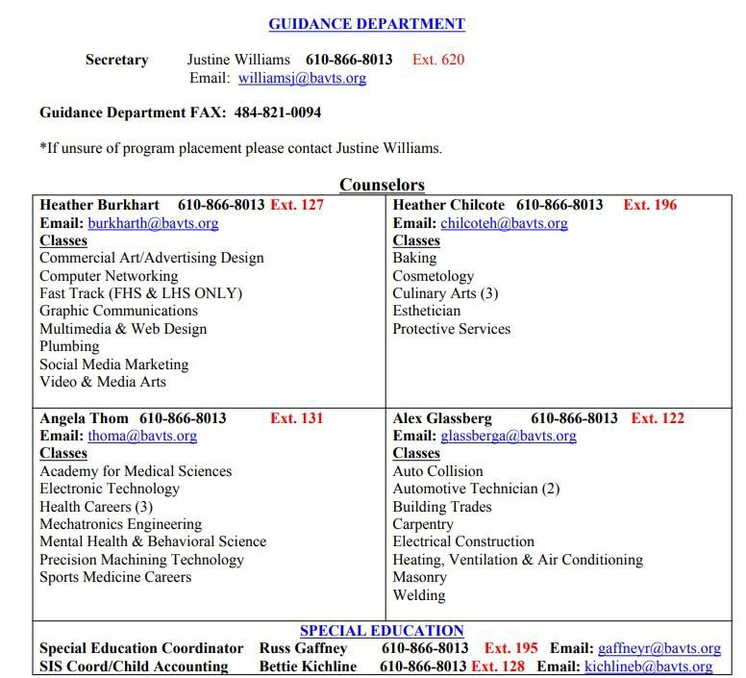
BAVTS utilizes the computerized grading system, eSchool, to report the student’s grades to their parent/ guardian and sending school. This system reports each student’s quarterly lab grade, attendance, work ethic grade and tardiness record, as well as appropriate comments selected by the instructor. Parents are able to login to the eSchool portal to view their student's progress and information. There is an email sent to parents/guardians at the beginning of each school year with directions on how to access the parent portal. Please contact Bettie Kichline, student information system coordinator (kichlineb@bavts.org) with any questions.
34


The Ladder to Success
SCHOOL-TO-CAREER PROGRAM

Working Papers
PA State Law requires every person less than 18 years of age to obtain an employment certificate before working in any establishment or occupation. The required papers can be se- cured through the Pupil Service or Guidance Office at the sending school district. Working papers are required for every individual under 18 years of age with a job.
Job Shadowing
During job shadowing, a student follows and observes for one or more days (no more than 3) to learn about a particular occupation or industry. A student is placed in a business or organization in which she has ex- pressed an interest or shown an aptitude. This activity allows a student to receive firsthand career information, educational requirements, and experience day-to-day activities involved in the occupation being observed. (Students may not do any activity which may result in an “immediate advantage” to the employer; it is an “observation only” activity)
Internship
An internship includes training at a business/industry worksite for a specific period of time to learn about a particular industry or occupation without compensation. The workplace permits internship students to work under direct supervision to gain exposure to a particular occupation. The state of Pennsylvania allows a student a maximum of sixty hours of unpaid, hands-on training as an extension of the classroom in each individual placement. Students’ workplace activities may include special projects, a sample of tasks from different jobs, or tasks from a single occupation.

Cooperative Education
This program is offered to qualifying students from all participating districts.The School-to-Career staff will provide supervision, instruction, placement, and evaluation. Participation in the program is a privilege; therefore, an acceptable attendance record must be maintained. Potential employers must carry workmen’s compensation, pay by payroll, and possess the necessary clearances, which include:
- Act 114 Federal Criminal History Check
- Act 34 Pa State Criminal Record Check
- Act 151 Pa. State Child Abuse Clearance
The purpose of this program is to provide students, before graduation, a real opportunity to acquaint themselves with the “World of Work.” They will be given the opportunity to learn at a training station and earn a wage; accept responsibilities, direction and constructive criticism; and to be a truly responsible member of our nation’s workforce. This program is designed to be an extension of the classroom and is not for the purpose of paying bills or insurance.
35

Recommendations for employment will be based upon the student’s cumulative records. Therefore, only those students who have maintained satisfactory grades in their career and technical course, 80% or higher, and who have been approved by the instructor and high school Principal as having made adequate progress in learning and adjustment would be considered eligible for placement.
In order to receive school credit and to be excused from attending career and technical classes, a student must work a minimum of fifteen hours per week. If it is mutually acceptable, the employer and student may enter into an agreement for part-time work in addition to the school-to-career hours of placement. However, if the additional work interferes with the student’s school performance, by lowering grades or establishing an irregular attendance pattern, the student will be withdrawn from the program.

Procedures for Placement on Cooperative Education
- Student placement on Co-op involves both the School-to-Career Coordinator and the student’s instructor.
- Students will be rated as ready for Co-op placement by maintaining good grades, low absences and by skills and attitude development rated by their instructors. This rating system favors seniors over juniors or sophomores. Students must complete a minimum of six (6) quarters in the occupational area for which they seek a Co-op position.
- Students themselves may request Co-op placement but should do so through their instructor. If students approach the School-to-Career Coordinator, they will not be placed until the instructor is consulted.
- Necessary forms, which can be obtained from the School-to-Career Coordinator, will have to be processed between the student, his/her family, employer, and the sending high school before a student may begin work. A resume, driver’s license and insurance card are also required. A student may only be placed where the employer is subject to the provisions of the Fair Labor Standards Act, the Pennsylvania Minimum Wage laws and the Workers Act. Clearances are required if under the age of 18.
- Poor attendance and punctuality make students ineligible to participate in the School-to-Career program. Business and industry require that students have a good record before they will consider hiring.
- On the first and third Wednesday of each month, or every two weeks, all School-to-Career students must report to the scheduled meeting area. The sessions will be conducted by the School-to-Career Coordinator. The program uses the Capstone Curriculum for Cooperative and enhances and refines student’s skills as a worker. Following the session, the student will report to the worksite. Failure to meet the requirements may result in termination from School-to-Career placement.
- Working papers are not issued by BAVTS. They must be obtained through the student’s sending school. A parent/guardian must be present to obtain the application.
- If a student is absent from his/her home school, they are unable to attend work. Students who are absent from their School-to-Career job are required to call the Attendance Office at 610-866-8013, Ext. 100. This information will be recorded on each student’s lab record and a note will be placed in their School- to-Career folder. BAVTS will follow-up with the sending school to determine the student’s attendance pattern. Failure to turn in an excuse after three (3) days results in an unexcused absence.
- Students and parent/guardians are responsible for transportation to and from the School-to- Career work locations.
- In the event of a student suspension from the sending school or BAVTS, the student is not eligible to attend work.
- If a student quits a job placement or is fired, they must report to school immediately following the incident (the same day).
- In the event of inclement weather or extended layoff, the student must report to the work-related lab. The
student must report the circumstance to the School-to-Career office on the same day.
- The student must return to school to participate in NOCTI exam.
- Students are required to take a test about the rules of the co-op program.
36

Students are required by the School-to-Career contract to attend the Annual Appreciation Breakfast. Failure to participate in this event will result with a “zero” being averaged into the fourth quarter grade. Student and parent/guardian will be required to sign the School-to-Career contract indicating they have been notified of this policy. There will be no exceptions unless prior authorization has been given by the School-to-Career A three-hour, in-school makeup assignment must be completed in order to receive any credit.

PENNSYLVANIA SKILLS CERTIFICATE/ INDUSTRY SKILL CERTIFICATES
Students in most departments are given the opportunity to participate in the Pennsylvania Skills Certificate Program sponsored by the Pennsylvania Department of Education. However, many programs at BAVTS have Industry that are offered in lieu of the National Occupational Competency Testing Institute program and offer certificates unique to their industry.
The PA Skills Certificate program recognizes outstanding students by awarding the Pennsylvania Skills Certificate to 12th grade students and outstanding underclassmen who demonstrate mastery of National Occupational Competency Testing Institute or other State recognized and accepted Industry
37
SCHOOL CLOSING
The Bethlehem Area Vocational-Technical School and its cooperative school districts operate on a common calendar. Special closings in the event of snow or other emergencies will be announced by the sending school. Students are urged to listen to local radio stations, television and internet and observe only the school closings of their own school districts. If the student’s sending school closes, that student will not report to BAVTS. If the student’s sending school is open, that student will report to BAVTS as scheduled unless the local radio stations report that BAVTS is closed. If there is a one/two hour delay, Freedom and Liberty High School students report to BAVTS. Northampton High School or Saucon Valley High School students will not be in attendance for the A.M. session at BAVTS. School closing is considered a school-related ab- sence. School closings are the responsibility of the sending school districts. BAVTS has no jurisdiction over the closing of school.






  Schools
The Family Educational Rights and Privacy Act (FERPA) afford parent/guardians and students over 18 years of age (“eligible students”) certain rights with respect to the student’s education records. These rights are:
The right to inspect and review the student’s:
- Education records within 45 days of the day the school received a request for access. Parent/Guardians or eligible students should submit to the school principal (or appropriate school official) a written
request that identifies the records) they wish to inspect. The school official will make arrangements for ac- cess and notify the parent/guardian or eligible student of the time and place where the records may be in- spected.
- The right to request the amendment of the student’s education records that the parent/guardian or eligible student believes are inaccurate or misleading. The parent/guardians or eligible students may ask the school to amend a record that they believe is inaccurate or misleading. They should write the school Prin- cipal (or appropriate official), clearly identify the part of the record they want changed, and specify why it is inaccurate of misleading. If the school official decides not to amend the record as requested by the parent/guardian or eligible student, the school official will notify the parent/guardian or eligible student when notified of the right of a hearing.

- The right to consent to disclosures of personally identifiable information contained in the student’s educa- tion record, except to the extent that FERPA authorizes disclosure without consent. One exception, which permits disclosure without consent, is disclosure to school officials with legitimate educational interests. A school official is a person employed by the school as an administrator, supervisor, instructor, or support staff member (including health or medical staff and law enforcement unit personnel): a person serving on the School Board; a person or company with whom school has contract to perform a special task (such as an attorney, auditor, medical consultant, or therapist): a parent/guardian or student serving on an official committee, such as a disciplinary or grievance committee, or assisting another school official in performing his or her task. A school official has a legitimate educational interest if the official needs to review an education record in order to fulfill his other professional responsibility. Upon request, the school discloses education records without consent to officials of another school district in which a student seeks or intends to enroll.

- The right to file a complaint with the U.S. Department of Education concerning alleged failures by the School District to comply with the requirements of FERPA. The name and address of the Office that admin- isters FERPA is:
Family Policy Compliance Office
U.S. Department of Education 400 Maryland Avenue, SW Washington, DC 20202-4605

- As required by Federal law, parent/guardian consent is not required for the release of Directory Information, which is information contained in an education record of a student that would not generally be considered harmful or an invasion of privacy if disclosed. The Bethlehem Area Vocational Technical School desig- nates the following as directory information: the student’s name, address, telephone number (with the excep- tion of unlisted telephone numbers), date and place of birth. A parent/guardian or eligible student may notify in writing of their refusal to allow the district to release Directory Information without prior con- sent. Except for Directory Information, all personally identifiable records directly related to the student shall be kept unless the parent/guardian signs a consent form releasing such information.
38



PPRA affords parent/guardians certain rights regarding our conduct of surveys, collection and use of infor- mation for marketing purposes, and certain physical exams. These include the right to:
Consent before students are required to submit to a survey that concerns one or more of the following protect- ed area (“protected information survey”) if the survey is funded in whole or in part by a program of the U.S. Department of Education:

- Political affiliations or beliefs of the student or student’s parent/guardian;

- Mental or psychological problems of the student to student’s family;

- Sex behavior or attitudes;

- Illegal, anti-social, self-incriminating, or demeaning behavior;
- Critical appraisals of others with whom respondents have close family relationships;

- Legally recognized privileged relationships, such as with lawyers, doctors, or ministers;
- Religious practices, affiliations, or beliefs of the student or parent/guardians; or

- Income, other than as required by law to determine program eligibility.

Receive notice and an opportunity to opt a student out of:

- Any other protected information survey, regardless of funding;
- Any non-emergency, invasive physical exam or screening required as a condition of attendance, administered by the school or its agent, and not necessary to protect the immediate health and safety of a student, except for hearing, vision, or scoliosis screening, or any physical exam or screen permitted or re- quired under State Law; and
- Activities involving collection, disclosure, or use of personal information obtained from students for marketing or sales or otherwise distributing the information to others.
Inspect upon request and before administration or use:

- Protected information surveys of the students

- Instruments used to collect personal information from students for any of the above marketing, sales, or other distribution purposes; and instructional material used as part of the educational curriculum
These rights transfer from the parents to a student who is 18 years old or an emancipated minor under State law
39

Notification of Rights, continued
These rights transfer from the parent/guardians to the student who is 18 years old or an emancipated minor under State Law.
Bethlehem Area Vocational-Technical School will develop and adopt policies, in consultation with parent/ guardians, regarding these rights, as well as arrangements to protect student privacy in the administration of protected information surveys and the collection, disclosure, or use of personal information for marketing, sales, or other distribution purposes. BAVTS will directly notify parent/guardians of these policies at least an- nually at the start of each school year and after any substantive changes. BAVTS will also directly notify through U.S. mail or e-mail, parent/guardians of students who are scheduled to participate in the specific ac- tivities or survey. BAVTS will make this notification to parent/guardians at the beginning of the school year if the School has identified the specific or approximate dates of the activities or survey at that time. For sur- veys and activities scheduled after the start, parent/guardians will be provided reason- able notification of the planned activities and surveys listed below and be provided an opportunity to opt their child out of such activ- ities and surveys. Parent/ Guardians will also be provided an opportunity to review any pertinent surveys. Fol- lowing is a list of the specific activities and surveys covered under this requirement:
  - Collection, disclosure, or use of personal information for marketing, sales or other distribution.
  - Administration of any protected information survey not funded in whole or in part by the Department of Education.
  - Any non-emergency, invasive physical
  - examination or screening as described above.
Parent/guardians who believe their rights have been violated may file a complaint with:
EMERGENCY DRILLS
Fire drills must be held in order to ensure that every student is aware of the purpose of drills and to know what staging area to report to when evacuating the building.
- All doors are to be closed and lights are
to be turned off.
- All panic switches are to be turned off.
- All students are to leave the lab areas.
- Instructors will inform all students of the procedures and regulations governing fire drills.
VISITORS
BAVTS welcomes visitors as long as appropriate procedures are followed. Secondary students who wish to visit a Career and Technical program must have prior approval from his/her sending school counselor. Former students are asked to call and schedule an appointment after school hours to visit. All persons who enter BAVTS must register with the security desk located in the main lobby. The
visitor will be given be given a visitor’s pass that must beworn while they are in the building. A log book is provided for the person to state his/her reason for visiting.
Family Policy Compliance Office
U.S. Department of Education
400 Maryland Ave, SW Washington, DC 20202-5901

STUDENT WORK PROJECTS
All work done at BAVTS is undertaken solely on the basis of the educational value involved. It shall be understood that all work is performed by stu- dents learning situation. No guarantee or war- ranty by the Bethlehem Area Vocational-Technical School exists. Neither BAVTS nor the instructors will assume any responsibility for damage or theft of personal property while on the premises of BAVTS.
LOST AND FOUND
The BAVTS lost and found department is maintained at the main lobby desk. Stu are responsible for the security and safety of their personal property (i.e., purses, wallets, money, tools, etc.). The school is not responsible for or replacement of any personal property.
40

School Insurance for Students
All students participating in a career and technical program are urged to participate in the insurance program offered by the home school. The cost of this insurance is minimal. Bodily injury and financial loss may occur through accidents. Insurance brochures, which thoroughly explain the policy, are given to each student early in the school year at the home school. The Administration at BAVTS strongly recommends that every student participate in their home school insurance program. BAVTS does not provide coverage for students. Insurance is the responsibility of the student and/or parent/guardian whichever is appropriate.

Title IX Notice
Title IX Coordinator: Debra Miller, Business Manager Office address: 3300 Chester Ave, Bethlehem PA 18020 Email: millerd@bavts.org
Telephone number: 610-866-8013

Bethlehem Area Vocational-Technical School is committed to complying fully with all Federal and state laws banning discrimination on the basis of gender, sexual orientation, gender identity/expression with regard to instructional programs, extracurricular activities, and employment practices. Any person who believes him- self or herself to be a victim of sex discrimination by the Bethlehem Area Vocational-Technical School or its employees or students should contact the Title IX Coordinator.

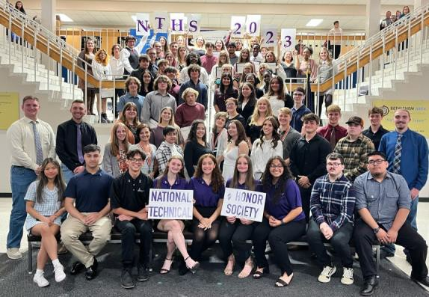
By clicking on a link below you will be forwarded to the current policy. Policies are reviewed and re- vised as needed by our Joint Operating Committee.

https://www.bethlehemavts.org/bavts-operation



41

5/19/22, 10:04AM BoardDocs® PL
JI� BETHLEHEM AREA
� VOCATIONAL-TECHNICAL SCHOOL

Book Section Title Code Status
Policy Manual 100 Programs
Nondiscrimination in School and Classroom Practices 103
Active

Adopted Last Revised
November 14, 2007

January 4, 2022

Authority_
The Joint Committee declares it to be the policy of this school to provide an equal opportunity for all students to achieve their maximum potential through the programs offered in the school regardless of race, color, age, creed, religion, gender, sexual orientation, gender identity, gender expression, ancestry, national origin, marital status, pregnancy or handicap/disability.[1J[21[JJI'.:1:l[�JL§l[Zlrn.1[21[101[11J[12J [131
The school will provide to all students, without discrimination, course offerings, counseling, assistance, employment, and extracurricular activities. The school will make reasonable accommodations for identified physical and mental impairments that constitute handicaps and disabilities, consistent with the requirements of federal and state laws and regulations.
Note: Sexual harassment is a specific form of unlawful harassment which violates a Federal civil rights statute, Title IX. This policy prohibits all forms of harassment based on characteristics other than an individual's sex, as named above. Sexual harassment is prohibited by a separate policy with different provisions. That policy, which follows in the Joint Committee Policy Manual, is designated Policy 103.1. [14]
The Joint Committee encourages students and third parties who have been subject to discrimination to promptly report such incidents to designated employees.
The Joint Committee directs that complaints of discrimination will be investigated promptly, and corrective action be taken when allegations are substantiated. Confidentiality of all parties will be maintained, consistent with the school's legal and investigative obligations.[151[16]
No reprisals nor retaliation will occur as a result of good faith charges of discrimination.
Delegation of ResP-onsibility_
In order to maintain a program of nondiscrimination practices that is in compliance with applicable laws and regulations, the Joint Committee designates the Business Administrator or his/her designee as the school's Compliance Officer.
The Compliance Officer will publish and disseminate this policy and complaint procedure at least annually to students, parents/guardians, employees and the public. Nondiscrimination statements will include the position, office address and telephone number of the Compliance Officer.
The Executive Director or designee is responsible to monitor the implementation of nondiscrimination procedures in the following areas:
http s://go.boardd ocs.com/palbthv/Board.nsf/Private?open&Iogin# 1/4

- Curriculum and Materials - Review of curriculum guides, textbooks and supplemental materials for discriminatory bias.
42

- Training - Provision of training for students and staff to identify and alleviate problems of discrimination.
- Student Access - Review of programs, activities and practices to ensure that all students have equal access and are not segregated except when permissible by law or regulation.
- School Support - Assurance that like aspects of the school program receive comparable support as to staffing and compensation, facilities, equipment, and related matters.
- Student Evaluation - Review of tests, procedures, and guidance and counseling materials for stereotyping and discrimination.

The Executive Director or designee will be responsible to complete the following duties when receiving a complaint of discrimination:
- Inform the student or third party of the right to file a complaint and the complaint procedure.
- Inform the complainant that s/he may be accompanied by a parent/guardian during all steps of the complaint procedure.
- Notify the complainant and the accused of the progress at appropriate stages of the procedure.
- Refer the complainant to the Compliance Officer if the Executive Director is the subject of the complaint.

Guidelines
Complaint Procedure – Student/Third Party
Step 1 – Reporting
A student or third party who believes s/he has been subject to conduct that constitutes a violation of this policy is encouraged to immediately report the incident to the Executive Director.
A school employee who suspects or is notified that a student has been subject to conduct that constitutes a violation of this policy will immediately report the incident to the Executive Director.
If the Executive Director is the subject of a complaint, the student, third party or employee will report the incident directly to the Compliance Officer.
The complainant or reporting employee is encouraged to use the report form available from the supervisor, but oral complaints will be acceptable.

Step 2 – Investigation
Upon receiving a complaint of discrimination, the Executive Director will immediately notify the Compliance Officer. The Compliance Officer will authorize the Executive Director to investigate the complaint, unless the Executive Director is the subject of the complaint or is unable to conduct the investigation.
The investigation may consist of individual interviews with the complainant, the accused, and others with knowledge relative to the incident. The investigator may also evaluate any other information and materials relevant to the investigation.

The obligation to conduct this investigation will not be negated by the fact that a criminal investigation of the incident is pending or has been concluded.
43

Step 3 – Investigative Report

The investigator will prepare a written report within fifteen (15) days, unless additional time to complete the investigation is required. The report will include a summary of the investigation, a determination of whether the complaint has been substantiated as factual and whether it is a violation of this policy, and a recommended disposition of the complaint.
Findings of the investigation will be provided to the complainant, the accused, and the Compliance Officer.
Step 4 – School Action
If the investigation results in a finding that the complaint is factual and constitutes a violation of this policy, the school will take prompt, corrective action to ensure that such conduct ceases and will not recur.
Disciplinary actions will be consistent with the Student Code of Conduct, Joint Committee policies and school procedures, applicable collective bargaining agreements, and state and federal laws.
Appeal Procedure
- If the complainant is not satisfied with a finding of no violation of the policy or with the corrective action recommended in the investigative report, s/he may submit a written appeal to the Compliance Officer within fifteen (15) days.
- The Compliance Officer will review the investigation and the investigative report and may also conduct a reasonable investigation.
- The Compliance Officer will prepare a written response to the appeal within fifteen (15) days. Copies of the response will be provided to the complainant, the accused and the Executive Director who conducted the initial investigation.
- If the complainant is not satisfied with a finding of no violation of the policy or with the corrective action recommended in the investigative report, s/he may submit a written appeal to the Superintendent of Record, who will prepare a written response to the appeal within fifteen (15) days. Copies of the response will be provided to the complainant, the accused and the Executive Director who conducted the initial investigation. The complainant may appeal the Superintendent of Record’s response to the Joint Committee as a final step in the appeal procedure.

Legal 1. 24 P.S. 1310
  - 24 P.S. 1601-C et seq
  - 22 PA Code 4.4
  - 22 PA Code 12.1
  - 22 PA Code 12.4
  - 22 PA Code 15.1 et seq
  - 24 P.S. 5004
  - 43 P.S. 951 et seq
  - 20 U.S.C. 1681 et seq
  - 20 U.S.C. 6321

44
  - 29 U.S.C. 794
  - 42 U.S.C. 12101 et seq

  - 42 U.S.C. 2000d et seq
  - Pol. 103.1
  - 20 U.S.C. 1232g
  - 34 CFR Part 99
20 U.S.C. 1400 et seq
42 U.S.C. 1981 et seq
28 CFR Part 35
28 CFR Part 41
34 CFR Part 100
34 CFR Part 104
34 CFR Part 106
34 CFR Part 110
U.S. Const. Amend. I
U.S. Const. Amend. XIV, Equal Protection Clause Pol. 113.1
Pol. 113.2
Pol. 122
Pol. 138
Pol. 216
Pol. 218
Pol. 233
Pol. 317
Pol. 417
Pol. 517
44

5/19/22, 10:05 AM BoardDocs® PL
JI� BETHLEHEM AREA
� VOCATIONAL-TECHNICAL SCHOOL

Book Section Title Code Status Adopted
Policy Manual 100 Programs
Nondiscrimination on the Basis of Sex in School and Classroom Practices 103.1
Active

January 4, 2022

Purgose
The Joint Committee strives to provide a safe and positive learning climate for students and a safe and positive environment for all employees in the school. Harassment on the basis of sex is a form of unlawful harassment prohibited by Title IX, and will not be tolerated in any form.
Authority_
The Joint Committee adopts this policy to comply with requirements set forth by the U.S. Department of Education Final Rule, Nondiscrimination on the Basis of Sex in Education Programs or Activities Receiving Federal Financial Assistance, published in the Federal Register on May 19, 2020, after notice and comment rulemaking.
What is Title IX?
Title IX is a federal civil rights law which states:
No person in the United States will, on the basis of sex, be excluded from participation in, be denied the benefits of, or be subjected to discrimination under any education program or activity receiving federal financial assistance.
Definition of Sexual Harassment
For purposes of this policy, sexual harassment of students is defined as conduct on the basis of sex that satisfies one or more of the following:[1]
- An employee of the school's conditioning the provision of an aid, benefit, or service of the school on an individual's participation in unwelcome sexual conduct; also called quid pro quo (this for that) sexual harassment;
- Unwelcome conduct determined by a reasonable person to be so severe, pervasive, and objectively offensive that it effectively denies a person equal access to the school's education program or activity; or
- Sexual assault, dating violence, domestic violence, or stalking.
Note that the qualification of "severe, pervasive, and objectively offensive" applies only to "unwelcome conduct," and does not apply to incidents of quid pro quo sexual harassment, sexual assault, dating violence, domestic violence, or stalking. A single incident of these offenses is sufficient to constitute sexual harassment.
Also note that sexual assault, dating violence, domestic violence, and stalking are added to the definition of sexual harassment to align the elementary and secondary school definition of sexual
https://go.boarddocs.com/pa/bthv/Board.nsf/Private?open&login# 1/10
45

harassment with the Jeanne Clery Disclosure of Campus Security Policy and Campus Crime Statistics Act (Clery Act), which is applicable to postsecondary institutions, and to harmonize compliance obligations under both Title IX and the Clery Act. Although elementary and secondary schools are not subject to the Clery Act, under the 2020 Title IX Regulations, schools must look to the Clery Act in order to address these forms of sexual harassment if applicable. However, in no way do these definitions supersede the requirements that to be actionable under Title IX, the sexual harassment complained of must take place in the context of the school or school's education program or activity, as described below.
Examples of Sexual Harassment
Sexual harassment can be verbal, nonverbal, or physical conduct of a sexual nature. Examples of conduct that constitutes sexual harassment include, but are not limited to, sexual flirtations, advances, touching, or propositions; verbal abuse of a sexual nature; graphic or suggestive comments about an individual's dress or body; sexually degrading words to describe an individual; jokes; pin-ups; calendars; objects; graffiti; vulgar statements; abusive language; innuendoes; references to sexual activities; or overt sexual conduct.
Since sexual harassment is conduct, it can occur to any individual, regardless of sex, gender orientation or transgender status. Every person, regardless of demographic or personal characteristics or identity, e.g., LGBTQ or transgender, is entitled to the same protections from sexual harassment under this policy, and every individual will be treated with equal dignity and respect.
Additional Definitions
Actual knowledge means notice of sexual harassment or allegations of sexual harassment to a
school’s Title IX Coordinator or to any employee of the school.
Complainant means an individual who is alleged to be the victim of conduct that could constitute sexual harassment. An individual will have status as a complainant only if the individual is participating, or
attempting to participate, in the school’s education program or activity, as defined below, at the time of the alleged sexual harassment.
Dating violence means violence committed by a person:[2]
- Who is or has been in a social relationship of a romantic or intimate nature with the victim, and
- Where the existence of such a relationship will be determined based on a consideration of the following factors:
  - The length of the relationship.
  - The type of relationship.
  - The frequency of interaction between the persons involved in the relationship. Deliberate indifference means that the school’s response to sexual harassment is clearly unreasonable in light of the known circumstances.
Domestic violence includes felony or misdemeanor crimes of violence committed by a current or former spouse or intimate partner of the victim, by a person with whom the victim shares a child in common, by a person who is cohabitating with or has cohabitated with the victim as a spouse or intimate partner, by a person similarly situated to a spouse of the victim under the domestic or family violence laws of the jurisdiction receiving grant monies, or by any other person against an adult or youth victim who is protected from that person's acts under the domestic or family violence laws of the jurisdiction.[2]
Due process means that an accused perpetrator is entitled to presumption of non-responsibility, notice of the accusation, and a meaningful opportunity to respond to the allegation(s) in a meaningful time.
46

Education program or activity includes locations, events, or circumstances in which the school exercises substantial control over both the respondent and the context in which the sexual harassment occurs.[1][3][4]
Formal complaint means a document signed by a complainant and the Title IX Coordinator, or independently by the Title IX Coordinator, alleging sexual harassment against a respondent and requesting that the school investigate the allegation of sexual harassment. At the time of filing a formal complaint, a complainant must be participating in or attempting to participate in the education program or activity of the school. However, a formal complaint is not required for supportive measures that must be provided to anyone filing a formal or informal complaint.[1][4]
Rape shield laws limit the introduction of evidence or cross-examination of a rape complainant about past sexual behavior.
Respondent means an individual who has been reported to be the perpetrator of conduct that could constitute sexual harassment.
Sexual assault means any sexual act directed against another person, without consent of the victim, including instances where the victim is incapable of giving consent.[5]
Stalking means engaging in a course of conduct directed at a specific person that would cause a reasonable person to:[2]
- Fear for his/her safety or the safety of others; or
- Suffer substantial emotional distress.

When and Where Title IX Applies
Title IX prohibits sexual harassment that happens in the United States in a school's education program or activity. This includes locations, events, or circumstances where:
- The sexual harassment occurred as part of the school’s operations, and
- The school exercised substantial control over the alleged harasser and the circumstances in which the harassment occurred.
If the Title IX Coordinator decides that a complaint of sexual harassment does not meet the definition of sexual harassment in the Title IX Regulations as listed above, the Title IX Coordinator may dismiss the complaint as not a violation of Title IX. However, the alleged misconduct may violate a provision of the Student Code of Conduct, and the school may apply the applicable provision(s) of the appropriate Student Code of Conduct to resolve the complaint.
Delegation of Responsibility
The Joint Committee designates the Title IX Coordinator as the school’s Compliance Officer for this policy.
The Title IX Coordinator will publish and disseminate this policy and the complaint procedures to student, parents/guardians, employees, independent contractors, vendors, and the public.
The Title IX Coordinator will be trained in the requirements of this sexual harassment policy, and the identification and contact information for the Title IX Coordinator will be widely disseminated throughout the school by posting of information on the school website and written notices in every building and in school publications.
Duties of the Title IX Coordinator
The Title IX Coordinator must be free from conflicts of interest and bias and trained in how to serve impartially and avoid prejudgment of the facts at issue. The Title IX Coordinator may develop and
47

deliver awareness and educational programming for faculty, staff, students, parents, and community members.
The Title IX Coordinator will:
- Maintain current contact information and notices of nondiscrimination on the basis of sex in every school building and publication.
- Disseminate and implement this policy.
- Receive reports of sexual harassment in any mode, in person, online, telephone or U.S. mail, at any time, including non-business hours, through the contact information widely disseminated.
- Act promptly upon receipt of a complaint, providing to the complainant information about supportive measures and abiding by the desires of the complainant, notifying the complainant about the right to file a complaint and information on how to file a complaint. Supportive measures may also be provided to the respondent.
- Advise the complainant of the option of informal resolution of complaints, e.g., by mediation.
- Sign formal complaints along with the complainant (or the complainant's parents or legal caregiver) to initiate an investigation.
- Dismiss complaints on written notice from the complainant or complaints that do not meet the definition of sexual harassment above.
- Initiate and conduct an investigation of the complaint, or appoint an alternate or co-investigator.
- Keep records of the investigative steps, conduct interviews of complainant and respondent, document witnesses' statement, compile the investigative report.
- Arrange for live hearings, if they are to be conducted, and train in use of any technology to be used during a live hearing.
- Be aware of and look for and document patterns of complaints and patters of allegations against individual respondents.
If the Title IX Coordinator is the subject of the complaint, the Joint Committee will appoint a qualified independent investigator to handle the complaint.
The Title IX Coordinator must maintain the records of all investigations for seven (7) years.
Note that the completion of the written investigative report, the Title IX Coordinator must turn the investigation over to an independent decision-maker who will determine whether sexual harassment occurred and impose disciplinary sanctions as appropriate. The decision-maker will reach a determination regarding responsibility by applying the standard of evidence the school has designated for use in all formal complaints of harassment, the preponderance of evidence standard. The decision maker must then send both parties simultaneously a written determination as described below in the Grievance Process.
Notice of Sexual Harassment
The school receives notice of sexual harassment when a complaint is made to the Title IX Coordinator or to any employee of the school.
Who May File a Title IX Complaint
Any person, whether the person is the alleged victim or a parent, friend, or witness to sexual
48

harassment, may file a complaint of sexual harassment. Complaints may also be filed anonymously. No statute of limitations applies to filing a complaint of sexual harassment.
School Response to Notice of Sexual Harassment
When notice of sexual harassment is received by the Title IX Coordinator or by any school employee, the school is considered to have actual knowledge of the complaint of sexual harassment, and has a duty to respond in a manner that is not deliberately indifferent. The school’s response will be considered deliberately indifferent only if it is clearly unreasonable.
Upon receipt of the complaint, the Title IX Coordinator will provide reasonable and appropriate supportive measures to the complainant, as defined below, in order to restore or preserve equal educational access, without treating a respondent as responsible until the conclusion of a fair and impartial grievance process as described below. The Title IX Coordinator will take the wishes of the complainant into consideration, but not unduly burden the respondent. The Title IX Coordinator may also provide supportive measures to the respondent, as appropriate.
The respondent to a complaint of sexual harassment may be removed from school on an emergency basis if reasonable threat of harm is present. If the respondent is an employee, the employee may be placed on administrative leave during the investigation. In both cases of emergency removal or placement on administrative leave, the due process rights of the accused must be preserved by providing notice of charges and an opportunity to respond.
Supportive Measures
Supportive measures mean nondisciplinary, nonpunitive individualized services offered as appropriate, and as reasonably available, without fee or charge to the complainant, before or after the filing of a formal complaint, or where the complainant indicates no formal complaint will be filed. Such measures are designed to restore or preserve equal access to the recipient's education program or activity without unreasonably burdening the other party, including measures designed to protect the safety of all parties or the recipient's educational environment, or deter sexual harassment. The Title IX Coordinator must take the wishes of the complainant into consideration, and must keep the supportive measures confidential.[1][4]
In order to treat both complainant and respondent equally, the Title IX Coordinator must offer supportive measures to the respondent, under the same conditions as described above.
Supportive measures may include counseling, extensions of deadlines or other course-related adjustments, modifications of work or class schedules, campus escort services, mutual restrictions on contact between the parties, changes in work or housing locations, leaves of absence, increased security and monitoring of certain areas of the campus, and other similar measures. The recipient must maintain as confidential and supportive measures provided to the complainant or respondent, to the extent that maintaining such confidentiality would not impair the ability of the recipient to provide the supportive measures. The Title IX Coordinator is responsible for coordinating the effective implementation of supportive measures.
This definition of supportive measures permits a wide range of individualized services intended to meet the purposes stated above and to fulfill school obligations under IDEA, Section 504, and ADA.
Retaliation
Retaliation for reporting a complaint of sexual harassment is prohibited. However, prohibition of retaliation will not chill or infringe an individual's fundamental First Amendment rights.
Making False Statements

Intentionally making false statements in bad faith may be disciplined under the school’s code of conduct.
49

The Grievance Process

- Basic Requirements of the Grievance Process
The school’s grievance process will:
  - Treat complainants and respondents equitably by providing supportive measures to the complainant and respondent that does not unreasonably burden the respondent and by providing remedies to a complainant where a determination of responsibility for sexual harassment has been made against the respondent.
  - Design remedies so that equal access to the school’s education program or activity is restored or preserved. Remedies will require an objective evaluation of all relevant evidence - including both inculpatory and exculpatory evidence - and provide that credibility determinations may not be based on a person's status as a complainant, respondent, or witness.
  - Authorize the Title IX Coordinator as investigator, with authority to designate alternate investigators or co-investigators.
  - Ensure that all investigators receive training to identify relevant issues and collect those issues in the summary of the investigation.
  - Include a presumption that the respondent is not responsible for the alleged conduct until a responsibility determination is made at the conclusion of the grievance process.
  - Include in the grievance process reasonably prompt time frames for conclusion of the process, including reasonably prompt time frames for filing and resolving appeals, and a process that allows for a temporary delay of the grievance process or the limited extension of time frames for good cause with written notice to the complainant and the respondent of the delay or extension and the reasons for the action. Good cause may include considerations such as the absence of a party, a party’s advisor, or a witness; concurrent law enforcement activity; or the need for language assistance or accommodation of disabilities.
  - May not require, allow, rely upon, or otherwise use questions or evidence that constitute, or seek disclosure of, information protected under a legally recognized privilege, for example, physician patient confidentiality or rape shield laws, unless the person holding such privilege has waived the privilege.
  - Will, as stated above, ensure that the Title IX Coordinator retain all records pertaining to the investigation, determination of responsibility, outcome of any appeal(s), and documentation of supportive measures and remedies for seven (7) years.
  - Provide that all materials used to train Title IX Coordinators, investigators, decision-makers, and any person who facilitates an informal resolution process be made public upon request for inspection by members of the public.
- Informal Resolution of Complaints
  - An informal resolution process that does not involve a full investigation and adjudication, such as mediation, may be initiated, but only after the complainant has filed and signed a formal complaint with the Title IX Coordinator.
  - Voluntary written requests form both parties seeking informal resolution must be provided to the Title IX Coordinator.
  - The Title IX Coordinator must provide the parties with a written notice disclosing the allegations.
  - The informal resolution process may be initiated even after a formal complaint investigation has begun, at any time prior to reaching a determination regarding responsibility.
  - The informal resolution process cannot be used in any case where a school employee is charged with sexually harassing a student.
50

  - At any time prior to agreeing to a resolution of the complaint any party has the right to withdraw from the informal resolution process and resume the formal grievance process.
  - For an informal resolution, any individual designated to facilitate the informal resolution will be trained in the provisions of this policy and in informal resolution processes, and must be free from conflict and bias.
The informal resolution process cannot be used to resolve allegations that an employee sexually harassed a student.
- Formal Resolution of Complaints
Upon receipt of a formal complaint, signed by the complainant, the Title IX Coordinator must provide the following written notice to the complainant and respondent, if known:
  - Notice of the allegations potentially constituting sexual harassment, including sufficient details known at the time and giving parties sufficient time to prepare a response before any initial interview.
  - Notice of the elements of the school’s grievance process, including any informal resolution process.
  - Notice that the respondent is presumed not responsible for the alleged conduct and that a determination regarding responsibility is made at the conclusion of the grievance process.
  - Notice that the parties may have an advisor of their choice, who may be, but is not required to be, an attorney, and that they may inspect and review evidence.
  - Notice that knowingly making false statements or knowingly submitting false information during the grievance process is prohibited.
The Title IX Coordinator may proceed to file a formal complaint independently, against the wishes of the complainant. However, if the Title IX Coordinator signs the complaint independently, the Title IX Coordinator must state specific, clear circumstances justifying signing a complaint to initiate an investigation despite the wishes of the complainant, and to support whatever choice is made.
If the Title IX Coordinator decides to investigate allegations about the complainant or respondent that are not included in the original notice, the Title IX Coordinator must advise the parties.
- Investigation of Formal Complaints
When investigating a formal complaint, the Title IX Coordinator and any co-investigator(s), as well as any investigators appointed by the Title IX Coordinator must:
  - Provide an equal opportunity for the parties to present witnesses, including fact and expert witnesses, and other inculpatory and exculpatory evidence.
  - Not restrict either party from discussing the allegations under investigation or from gathering and presenting relevant evidence.
  - Provide the parties with the same opportunities to have others present during any grievance proceeding, including the opportunity to be accompanied to any related meeting or proceeding by the advisor of their choice, who may be, but is not required to be, an attorney. However, the investigator may establish restrictions regarding the extent to which any advisor may participate in the proceeding, and these restrictions must be applied uniformly to all advisors.
  - Provide, to a party whose participation is invited or expected, written notice of the allegations potentially constituting sexual harassment.

  - Provide both parties an equal opportunity to inspect and review any evidence obtained as part of the investigation.
51

Prior to completion of the investigative report, the Title IX Coordinator must send to each party and the
party’s advisor, if any, the evidence subject to inspection and review, in an electronic format or a hard copy, and the parties must have at least ten (10) days to submit a written response, which the investigator will consider prior to completion of the investigative report.
The Title IX Coordinator will create an investigative report that fairly summarizes relevant evidence and, at least ten (10) days prior to a live hearing (if a hearing will be scheduled), send to each party and the party’s advisor, if any, the investigative report in an electronic format or a hard copy, for their review and written response.
- Dismissal of Formal Complaints
The Title IX Coordinator may dismiss a formal complaint if the conduct alleged in the formal complaint: 1.

Would not constitute sexual harassment even if proved,

- Did not occur in the school’s education program or activity,
- The complainant requests dismissal of the complaint in writing, or
- If the conduct did not occur against a person physically in the United States. The Title IX Coordinator may also dismiss the complaint if the respondent is no longer enrolled or employed by the school; or specific circumstances prevent the Title IX Coordinator from gathering evidence sufficient to determine if sexual harassment occurred. If the formal complaint is dismissed, the Title IX Coordinator must promptly send written notice of the dismissal and reason(s) simultaneously to the parties.
- Live Hearings
The provision of a live hearing in a resolution of a formal complaint is optional at the elementary and secondary levels. If the school grievance process requires a live hearing, the hearing will be held after the Title IX Coordinator has sent the investigative report to the parties and before a determination of responsibility is final. The Title IX Coordinator will not be the decision-maker at the live hearing; another trained individual will conduct the live hearing.
If a live hearing is scheduled, either party to the formal complaint may request that the parties and their advisors be in separate rooms and communicate via technology and not in person. Advisors to the parties, but not the actual parties, may question and cross-examine parties and witnesses on relevant issues and evidence, and make credibility determinations, but the decision-maker at the live hearing may refuse to admit non-relevant questions. The decision-maker may also limit the opportunity for advisors to participate.
If a party does not have an advisor who can be present at the live hearing, the school must provide an advisor of the school’s choice without fee or charge to that party. The advisor provided may be, but is not required to be, an attorney. The Title IX Coordinator must see that an audio or audiovisual recording or transcript of any live hearing is created, and make a copy available to the parties for inspection and review.
If a live hearing is not part of the school’s grievance process, after the Title IX Coordinator has sent the investigative report to the parties and before a determination of responsibility is final, the decision maker who now takes over must allow each party the opportunity to submit written relevant questions to any party or witness, receive answers, and allow for additional limited follow-up questions from each party.
Questions and evidence about the complainant’s sexual predisposition or prior sexual behavior are not relevant, unless such questions and evidence are offered to prove that someone other than the respondent committed the conduct alleged.
52

Determination of Responsibility
After the Title IX Coordinator creates the investigative report, the Title IX Coordinator must hand over the report to an independent decision-maker who will issue a written determination regarding responsibility that specifies the evidentiary standard used in the determination. The Bethlehem Area Vocational- Technical School employs the preponderance of evidence standard in all determinations of responsibility for sexual harassment under Title IX.
The written determination must be provided to both parties simultaneously and must include the following:
- Identification of the allegations potentially constituting sexual harassment.
- Description of the procedural steps taken from the receipt of the formal complaint through to the determination, including any notifications to the parties, interviews with parties and witnesses, site visits, methods used to gather other evidence, hearings held and any other relevant procedural steps.
- Findings of fact supporting the determination.
- Conclusions regarding the application of the school's Code of Student Conduct or Joint Committee policies to the facts.
- A statement of the result and rationale for each allegation, including any disciplinary sanctions for the respondent, and whether remedies will be provided to the complainant.
The final determination must also provide information about procedures and bases for a timely appeal available to either party. If an appeal is filed, the determination becomes final on the date the appeal decision is supplied in writing to the parties. If neither party files a timely appeal, the determination is final when the appeal time limit expires.
The Appeals Process
Appeals can be filed for:
- Procedural irregularity that affected the outcome of the matter;
- New evidence that became available and that could have affected the outcome of the matter; or
- A provable conflict interest or bias on the part of the Title IX Coordinator, investigator(s), or decision-maker(s).

A new impartial decision-maker(s) not previously involved with the case must decide the appeal and provide a written decision simultaneously to both parties describing the result of the appeal and the rationale for the result.
When the final determination of responsibility is made and appeals are exhausted, the Title IX Coordinator is responsible for effective implementation of any remedies.
Publications Required
The provisions of this policy will be disseminated throughout the school and community and training in the policy requirements will be provided to employees, including staff and faculty, students, parents, and community members.
  - 34 CFR 106.30 2. 34 U.S.C. 12291
- 34 CFR 1064
- 34 CFR 106.45
- 20 U.S.C. 1092
53
34 CFR Part 106
Pol. 103

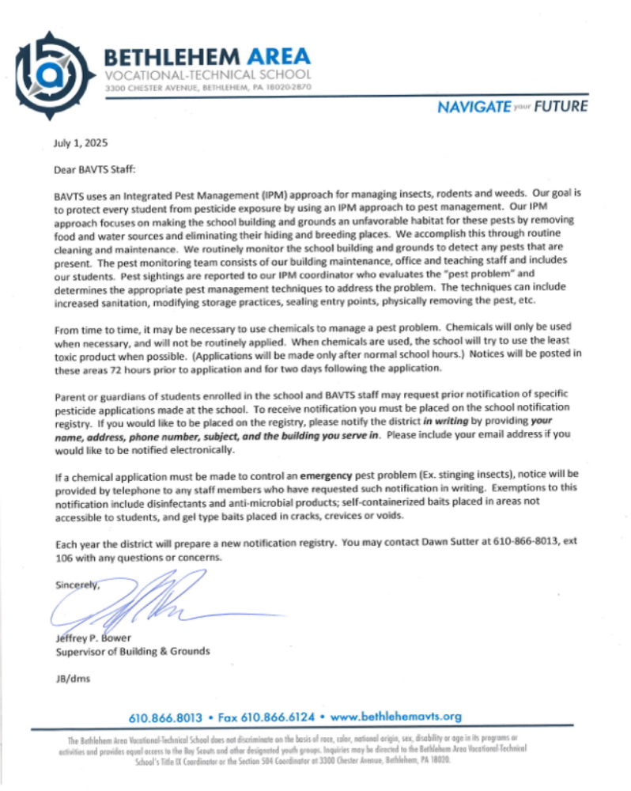

54



55

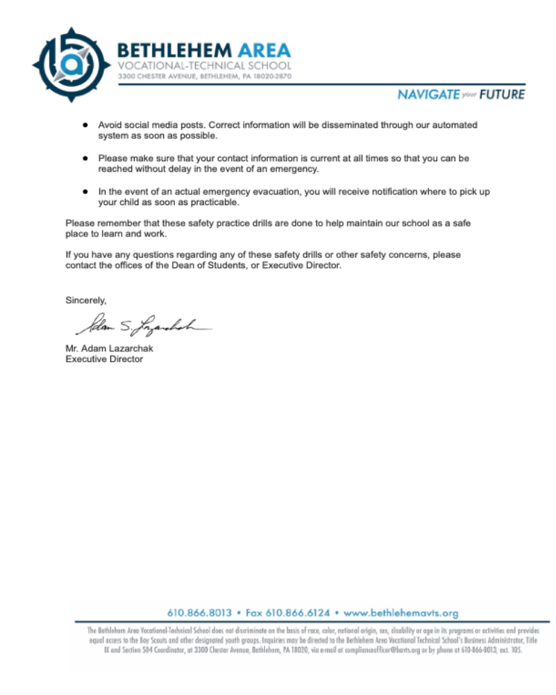

56

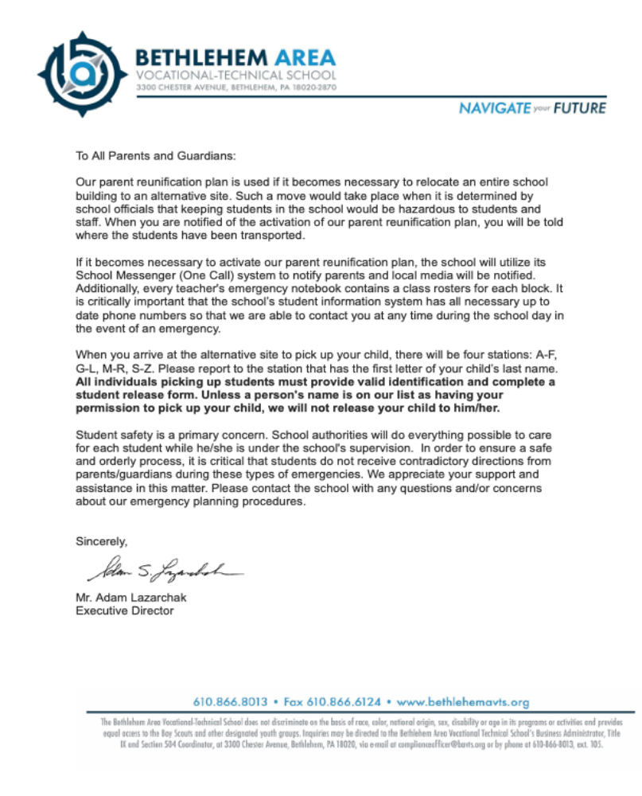

57

